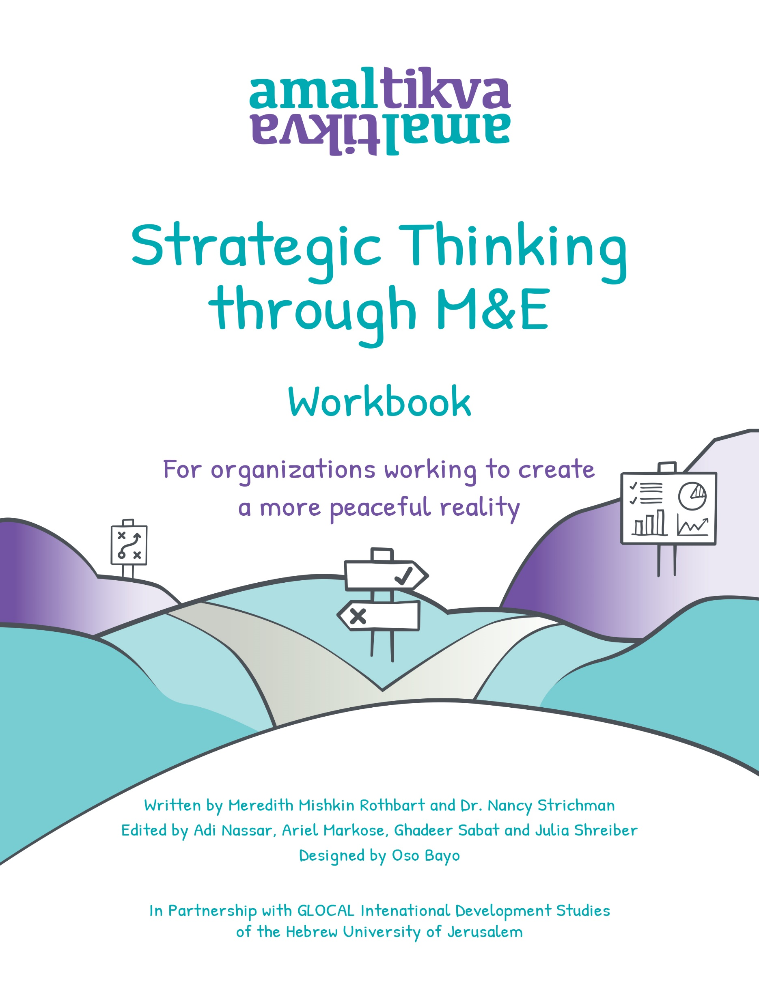

Acknowledgements

This workbook is the result of the combined efforts of special and committed individuals whose hard work and extraordinary dedication made this possible. We would like to thank Dr. Reut Barak Weekes and our other colleagues at the Glocal Program for International Development at the Hebrew University of Jerusalem for their partnership and contribution to the project. Special thanks to Judith Imholt, Nivine Sandouka, and Luisa Siemens from ALLMEP for thinking through the content and encouraging us to think more broadly. We would also like to thank our partners and colleagues who are generously contributing their insights and M&E experiences to the field.

Thank you to the brilliant Oso Bayo for her stunning design and unyielding patience so that we could get this just right. To Dr. Ruba Simaan who sensitively translated not just words but entire concepts and who worked with us in adapting the text so that all of our materials are available in English, Arabic and Hebrew. To Julia Schreiber for her hard work and attention to detail, accuracy, and integrity. To Sally Gottesman who encouraged us to turn important resources into an accessible workbook for the NGOs we support and for her ongoing support of Amal-Tikva. We are so grateful to you all.

We’d also like to thank our generous sponsor of this workbook, the Stern Philanthropic Fund, as well as our partners who made this workbook possible through supporting the Fieldbuilding360 program: The Aviv Foundation, B8 of Hope, Dorit Haverd and Richard Dale, The Morningstar Foundation and the United States Institute of Peace.

Thanks to the Amal Tikva team: Ghadeer Sabat Kort, Ariel Markose, Amitai Abouzaglo, Adi Nassar and Basheer Abu Baker for their input, contributions, and support in developing not only this workbook but the methodology behind it.

And to the one and only Dr. Nancy Strichman who dreamed this book into being, who wrote the massive full textbook version in one sitting, for letting us turn that book into this workbook, for helping us do it well, for including us in the process in the first place, and of course for being a true thought partner and friend, Amal-Tikva is what it is because of you. Thank you for everything.

Toda, Shukran, Thank you,

*Meredith*

Table of Contents

**4 Introduction**

**7 Section 1: Moving from Strategic Planning to M&E**

**28 Section 2: Developing a Plan for M&E**

**52 Section 3: Moving from M&E to Strategic Planning**

**60 Section 4: Communicating and Sharing Your Story**

Introduction

Peacebuilding organizations in our time stand at a critical crossroad. There have been so few resources in the field over the last few years that we have learned to operate with very little. At the same time this has been amidst a pandemic, political turmoil and resurging violence. These challenges have sapped motivation, drawn some of the top emerging leaders into different fields, and in some cases, contributed toward a culture of accepting the status quo versus disrupting it.

With NGO leaders working to raise sufficient funds and cope with complex cultural, national and logistical realities, peacebuilding organizations’ ambitions are not always matched with scalable models that can generate measurable impact. The influx of new international funding is now providing an opportunity to scale. How are we as a field supposed to make that jump?

In this workbook we provide an opportunity to try and take that jump together. We believe that if you, as an individual or as an organization, have made it to this workbook then you are ready to take your work to the next level. Of course, your efforts may already be making a valuable contribution to the field. Yet perhaps you need some guidance to measure, track, and adapt your initiatives as you go. That is what it means to be strategic and we are here to help you.

This workbook’s content is based on a more extensive guide written by our co-author Dr. Nancy Strichman. The comprehensive Monitoring and Evaluation Guidebook, along with the worksheets created for this workbook, are available in English, Hebrew and Arabic for download at [www.amal-tikva.org/resources](http://www.amal-tikva.org/resources). You can also find sample worksheets and practical case studies to accompany this guide at [www.amal-tikva.org/resources](http://www.amal-tikva.org/resources).

Strategic Thinking

What is strategic thinking? Why is it important to be strategic? With the use of this guide, we walk you through a process that shows how to make it entirely doable for your organization.

As we unpack the ideas, you can see that there is no reason to be intimated by the concept of being strategic. You will become more inclined to make sure this is an in-house operation, and it will reduce the chances of formal strategic plans being created that end up sitting unused in a drawer.

Strategic thinking will enable you to answer three key questions more easily:

1. What are you trying to accomplish?
2. What does your organization do?
3. What will society look like after you have succeeded?

This workbook will help you to articulate your strategy and then build a plan to make sure you stay on track. Setting up a feedback loop to monitor and evaluate your programs will ultimately enhance your overall effectiveness and relevance to the peacebuilding field. Our methodology flows in a cycle called ‘The Learning Cycle’ as outlined below.

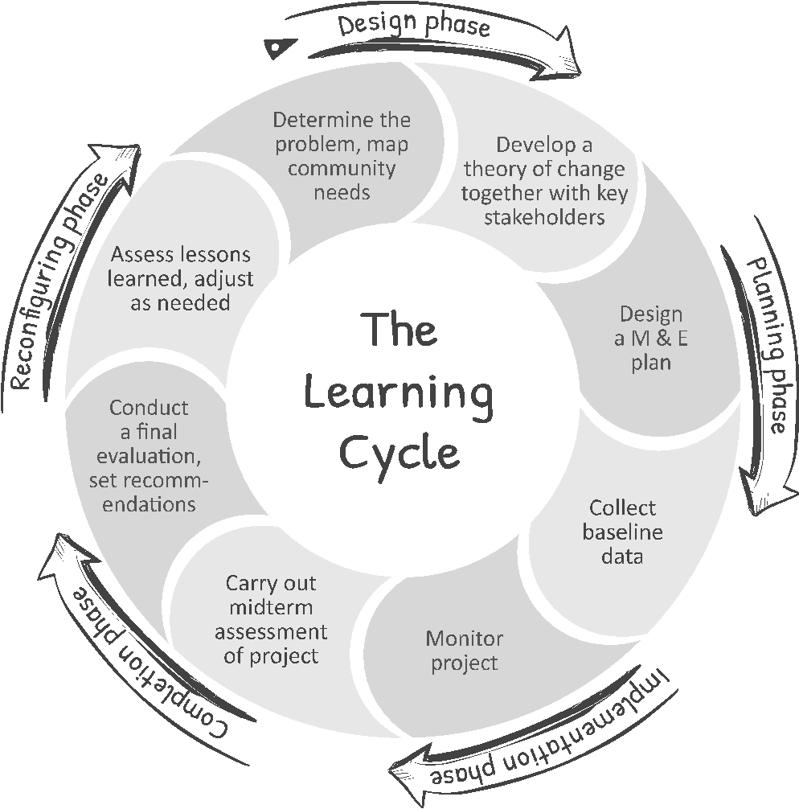

What is Monitoring & Evaluation (M & E)?

Your organization’s strategy is part of a cycle of continuous learning. The ability of your organization to learn from its efforts and to create a feedback loop for continuous improvement is an integral part of strategic thinking. The truth is that the **M & E is your work**, and it is an integral part of ensuring that you have ongoing strategic conversations at your organization.

Throughout this workbook we will be exploring each phase of the learning cycle noted above- from the design phase to the adaptation of your projects- and addressing how to institute an ongoing feedback loop at your organization. At each step you will see how the articulation of your strategic priorities and the use of M&E will allow you to continually improve your work as you go and ultimately, allow you to scale up your impact.

Please note, too often organizations seek an expert from outside the organization to perform M & E *for them*. M & E unfortunately can be perceived as an irrelevant donor requirement that takes time and energy away from the work itself. This thinking is harmful to your ability to continually sharpen your organizational strategy and enhance your contribution to peacebuilding efforts.

**DEFINITION OF TERMS**

**Monitoring** is the regular collection and analysis of information or data about your organization and each of its projects. The purpose of monitoring your work is to  **keep you on target** and allow you to **track progress over time**.

**Evaluation** is a bird’s eye view of various data collected over time, often in order to **measure whether your project activities have achieved your overall objectives.** While there are all kinds of evaluations, these processes generally are designed to help you improve strategy and gain knowledge to better inform future programming.[1]

Why is Monitoring & Evaluation important?

M & E enables you to:

* Outline the articulated change that you hope to see take place over time
* Track your progress toward desired outcomes
* Make sure your impact is linked to your day-to-day efforts
* Use resources more efficiently
* Adapt your program where needed to align with strategic priorities

M & E requires you to reflect on questions such as:

* Are you really implementing what you planned?
* How can you be sure that you are making progress toward your goals?
* Are your programs achieving a positive impact?
* In what ways can you improve your programs?

Together with strategic planning tools, the use of M & E helps to assure that you and your team can easily answer the following:[2]

* Our organization hopes to achieve: _________________________________________________
* So our organization does: _________________________________________________________
* And these efforts are resulting in: __________________________________________________
* We can be assured that these efforts are leading to desired results by measuring:

______________________________________________________________________________

Throughout this workbook, we explore the various phases of the learning cycle- walking you through a process that will help to shape a strategic approach to your peacebuilding efforts that is grounded in ongoing learning and adaptation.

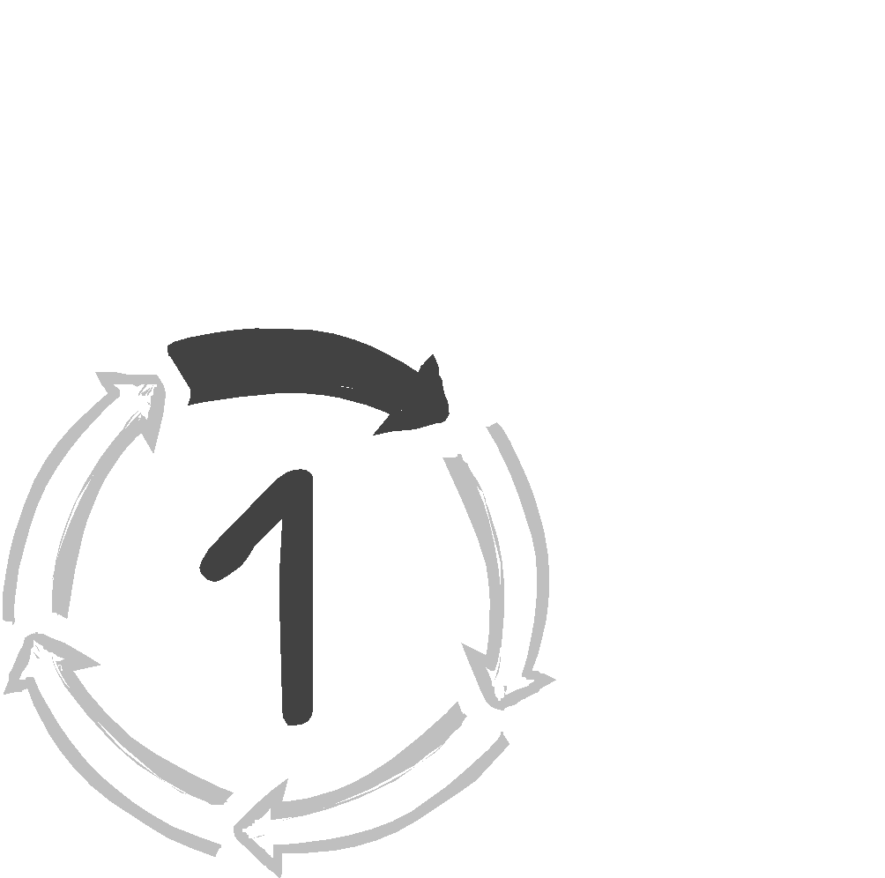

Section 1: Moving from Strategic Planning to M&E

In the following section, we outline various steps that will help you in articulating your strategy to advance peacebuilding both at an organizational and programmatic level. The various components addressed here will also be the basis for your M & E plan, representing an important step in instituting a ‘Learning Cycle’ at your organization.

We will first review steps that will help you to define the problem you are seeking to address, map key stakeholders and your own organizational capacities, identify risks and assumptions, and articulate a theory of change for your efforts based on a conflict analysis. We will also review various strategic planning tools, encouraging you to reflect on organizational values, mission and vision.  
  
Define the Problem

Often we set out with good intentions, yet sometimes fail to act in participatory ways or properly identify community needs. And then, when measuring what ‘success’ looks like, we limit our assessment to simply the number of programs implemented and how many individuals participated, irrespective of the impact on targeted communities.

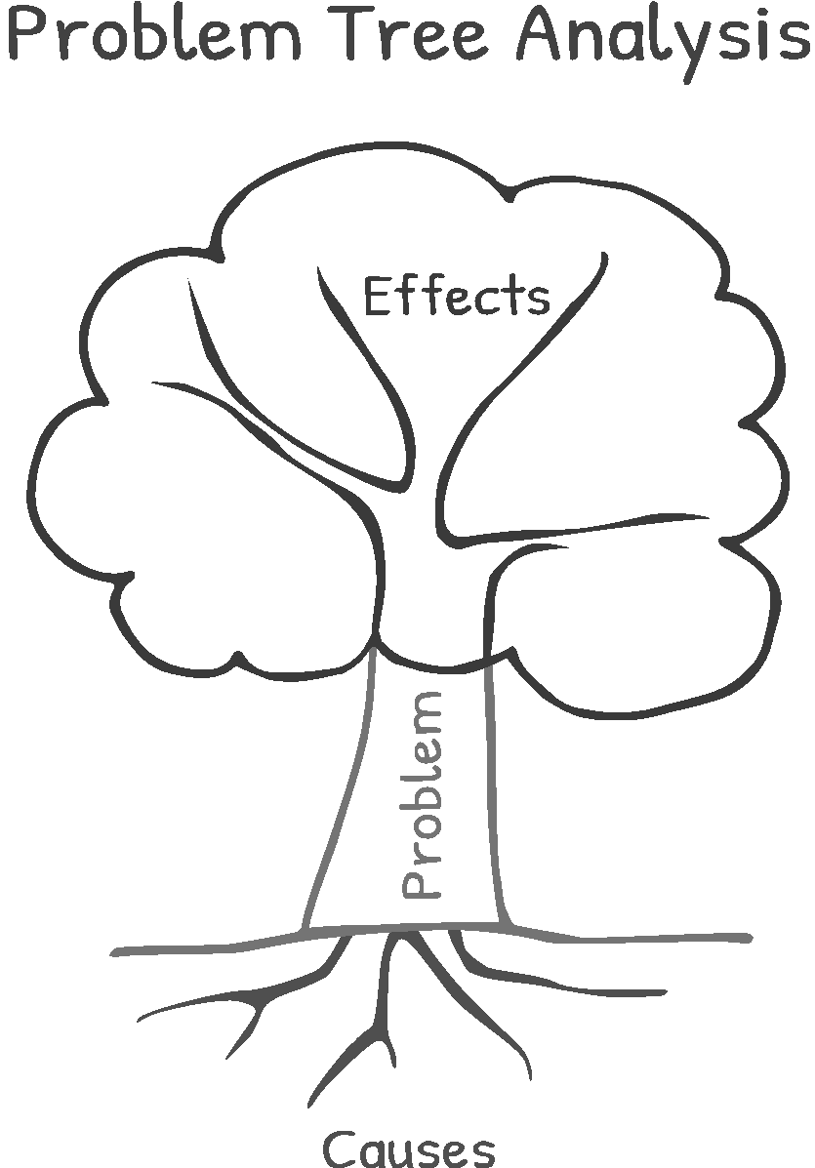What ultimately matters, however, is not how well projects are implemented, but how well the identified problem has effectively been addressed. This is why, prior to the design of any project or its implementation, it is essential to carefully articulate what the problem is that your organization is working to solve.

Civil society organizations, and certainly those in the field of peacebuilding, are seeking to address complex societal challenges. The problem tree analysis provides an opportunity for systematically thinking through these issues[3]. It will help guide strategy, preventing you from jumping to conclusions or offering solutions before you are able to grasp a full understanding of the problem you seek to solve.[4]

By identifying specific root causes of the problem, it is possible to develop concrete programs that explicitly address the identified issues. At the same time, mapping out the effects of the problem can help you define the target audience, time frame, and the setting for your programs. Your planned projects are then more likely to have a clearly defined impact.

When thinking about the root causes of the identified problem, consider economic, social and political factors, differing relationships and attitudes of conflicting parties, imbalance of opportunities, limits of political participation and resources.



Problem Tree Analysis – Worksheet

1. Start with the core problem. What is the main issue your organization seeks to address?  
     
   *If you need more than one core problem, copy and paste the “core problem” box to have a few more. We recommend no more than three ‘core problems’ for this exercise, as with the number of identified causes and effects of the problem below.
2. Think about the causes of the problem(s) you have identified. Map them below.
3. Think about the effect of the problem. As long as it continues not to be solved, what are the effects?

**The core of the problem is ….**

**________________________________________________________________________________________________________________________________________________________________________________________________**

**The effect is…**

**________________________________________________________________________________________________________________**

**It is caused by/ rooted in…**

**_____________________________________________________________________________________________________________**

**It is caused by/ rooted in…**

**________________________________________________________________________________________________________________________________________**

**__**

**It is caused by/ rooted in…**

**______________________________________________________________________________________________________________________________**

**The effect is…**

**___________________________________________________________________________________________________________________________________**

**The effect is…**

**________________________________________________________________________________________________**

Mapping Community Needs

Define your target population

Once you have identified the key problem and outlined its root causes, you should carefully reflect on who is affected by this problem and how to include them in addressing it.

Be inclusive as you set out to identify and map the needs of your target community in peacebuilding efforts. Your team will want to define this population as thoughtfully as possible, making sure to take into account factors such as age, gender, ethnicity, education, place of residence, family status, interests, personal abilities, needs, goals, capacities, and resources. It is important to keep in mind those factors among the target population that may change over time, such as employment status, housing situation, access to rights, job skills, etc.

Identify and Engage Stakeholders

Invite diverse members of your target community to be co-creators in your efforts, creating ongoing opportunities for engagement. Staying connected to your community can only strengthen your efforts. Doing so will help you keep in mind the big picture, including issues related to the broader context in which you operate.

As you explore your organizational strategy, make sure to create various opportunities to hear from different individuals who are informed about the kind of work that you do. Those with a ‘stake’ in your peacebuilding efforts include everyone from community activists, local leaders, and researchers to governmental officials, private sector representatives and funders.

You will want to be intentional and inclusive about inviting perspectives from both internal and external stakeholders to be part of your strategic conversations.[5] It is important to consider not only your target population but also other relevant stakeholders, while taking into account factors such as race, religion, gender, class, sexual preference, age, ethnicity, or profession of possible stakeholders.[6]

We also recommend establishing a platform for regular communication between community members and your organization. Offering opportunities for members of your target community to express their thoughts and exchange ideas is a valuable way to engage with your stakeholders while amplifying the longer-term effects of your programs. These platforms can take many forms such as community events, a social media group, or a mentorship program.



**DEFINITION OF TERMS**

* **Internal stakeholders (i.e., board, staff, and volunteers):** Your internal stakeholders are the individuals most familiar with the work of your organization. They are especially equipped to share insights on the linkage between your present strategies, organizational DNA and current performance as an organization.
* **External stakeholders (i.e., members of your target population, community partners, community leaders, funders):** Nurturing a ‘proximity’ with the target community is a critical piece in helping to ensure your effectiveness because so much of your work depends on the strength of this partnership. This can help your organization build and develop its network, while staying updated on new ideas and insights in the field.[7]

Identifying Stakeholder Needs

After identifying relevant stakeholders, it is helpful to add the role, relevance and needs of each stakeholder (see table below) in terms of how each factors into your peacebuilding efforts. You can use your problem tree as a reference point here. Mapping key stakeholders will help you to identify different needs of your community that you can factor into program design. The potential contribution of various stakeholders in terms of resources and skillsets is also worth noting. 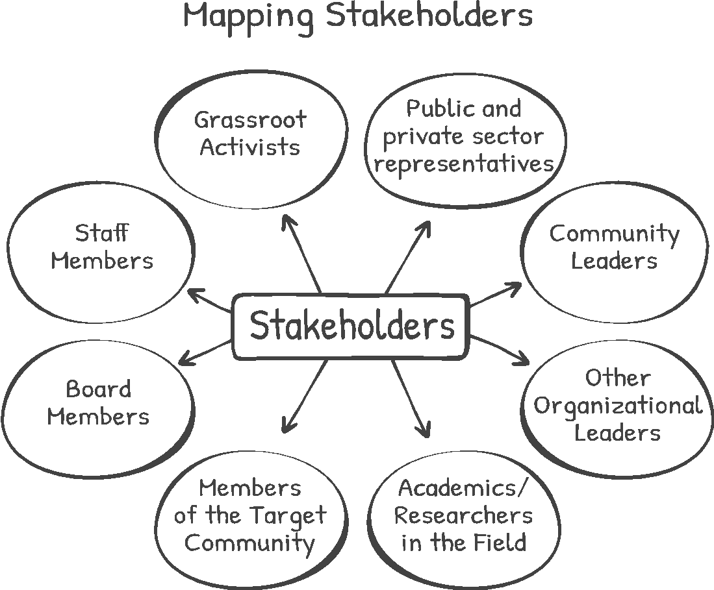

 **Mapping Stakeholders - Worksheet**

Reflect on your stakeholders by asking ‘who cares about our work and why?’ Brainstorm all the likely players who could be affected by your work. With your stakeholder map in hand, you can then make a list of stakeholders that also includes the responsibilities and relevance of each stakeholder.

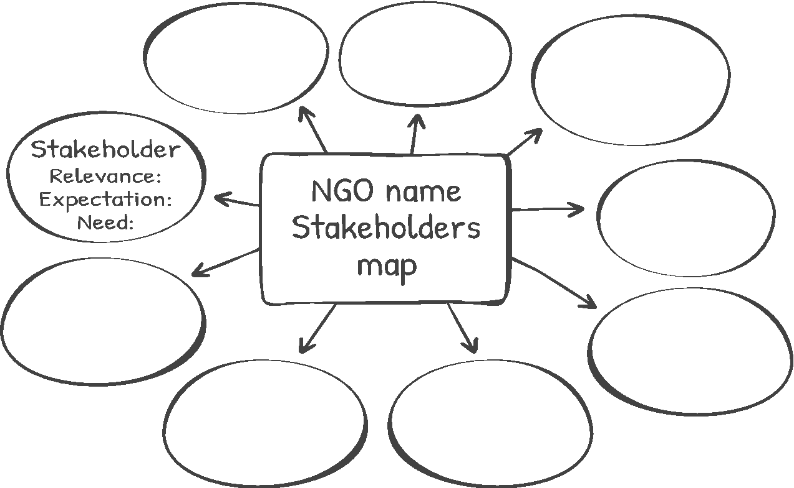



|  |  |  |  |
| --- | --- | --- | --- |
| **Stakeholder** | **Relevance** | **Expectation** | **Need** |
|  |  |  |  |
|  |  |  |  |
|  |  |  |  |
|  |  |  |  |



 Your Organization as a Stakeholder

– Mapping Capacity Worksheet

While assessing your stakeholders, it is important to acknowledge that your organization itself is a stakeholder. This worksheet will help you assess your organization’s capacity to implement your big picture strategy and long-term goals. We have suggested guiding questions to help you think about your organization’s structure, ecosystem, experience, and engagement with your community.

Organizational Structure and Capacity

* Does your organization have a leadership team? Who is on it?

________________________________________________________________________________________________________________________________________________________________________________________________________________________

* Who is involved in setting the ‘big picture’ and vision of your organization?

________________________________________________________________________________________________________________________________________________________________________________________________________________________

* How does your overall strategy get translated into workplans and programs?

________________________________________________________________________________________________________________________________________________________________________________________________________________________

* Is it clear who reports to whom? Who is accountable for program success and who is responsible for implementation? Who makes decisions?

________________________________________________________________________________________________________________________________________________________________________________________________________________________

* What kind of reporting and communication structure is in place to ensure that your team stays informed of progress and relevant issues?

________________________________________________________________________________________________________________________________________________________________________________________________________________________

* Are there clear job descriptions? Do staff understand their roles and responsibilities?

________________________________________________________________________________________________________________________________________________________________________________________________________________________

**Ecosystem**

* How does your organization interact with other institutions, leaders and stakeholders?

________________________________________________________________________________________________________________________________________________________________________________________________________________________

* What existing networks and coalitions help magnify the impact of your work?

________________________________________________________________________________________________________________________________________________________________________________________________________________________

* Have you explored partnerships with other organizations that could advance your goals?

________________________________________________________________________________________________________________________________________________________________________________________________________________________

* How do you ensure that you stay open to innovative ideas and new potential partners?

________________________________________________________________________________________________________________________________________________________________________________________________________________________

**Knowledge and Experience:**

* What unique knowledge, expertise and experience does your organization have for addressing work in your particular focus area?

________________________________________________________________________________________________________________________________________________________________________________________________________________________

* What gaps in expertise can you identify that would help you address this issue better?

________________________________________________________________________________________________________________________________________________________________________________________________________________________

* How have you created opportunities to learn from previous experiences both in your organization and from the broader field?

________________________________________________________________________________________________________________________________________________________________________________________________________________________

* What resources may your organization need to be more effective?

________________________________________________________________________________________________________________________________________________________________________________________________________________________

Engagement with your target community

* How does your organization engage with its target population in all aspects of your work?

________________________________________________________________________________________________________________________________________________________________________________________________________________________

* In what ways does your organization create opportunities for ongoing engagement and participation with various external partners?

________________________________________________________________________________________________________________________________________________________________________________________________________________________

* What types of efforts are made to ensure diverse participation in programs?

________________________________________________________________________________________________________________________________________________________________________________________________________________________

* How does the organization build its outreach with a broad range of community members in an effort to solicit multiple perspectives?

________________________________________________________________________________________________________________________________________________________________________________________________________________________



**Developing an Objective Tree **

Once you have mapped out the core problems that your organization seeks to solve and you have reflected upon your own organizational capacities, you can continue by turning the problem statements around to create your objectives. By transforming each problem statement into an objective, you are beginning to more specifically articulate your organization’s desired impact.[8]

For example:

Core Problem #1:   
Members of the conflicting groups do not trust each other.

Will be translated to

Objective #1:   
Build trust between members of the conflicting groups.



This example continues throughout the tree.

Can be translated to

Long-term Outcome #1: Decrease in prejudice and misperceptions of the other group.

Root of Problem #1:   
Existing prejudices and misperceptions of the other side of the conflict.





**Now you try! - Worksheet**

Will be translated to

Objective #1:   
____________________________________________________________

Core Problem #1:   
Certain citizens do not have equal access to healthcare.



This example continues throughout the tree.

Can be translated to

Long-term Outcome #1: ____________________________________________________________

Root of Problem #1:   
Healthcare is not provided in all languages which restricts access.





 Objective Tree Analysis – Worksheet

This worksheet allows you to practice transforming your problem tree into an objective tree.

1. As in the example above, transform the ‘core problem’ into your ‘core objective’.

2. Envision how society will be changed once your objective is achieved. What results does this provide? What are desired outcomes? Map them out below.

3. Reflecting upon your core objective and desired results, now take a moment to think about how this fits into an overall organizational purpose.

**Overall Purpose:**

**________________________________________________________________________________________________________________________________**

**Core Objective: ___________________________________________________________________________________________________________________________________________________________________________________________________________________________________**

**___________________________________________________**

**Desired Outcomes:**

**______________________________________________________________________________________________________________________________**

**Overall Purpose:**

**________________________________________________________________________________________________________________________________**

**Overall Purpose:**

**________________________________________________________________________________________________________________________________**

**Desired Outcomes:**

**______________________________________________________________________________________________________________________________**

**Desired Outcomes:**

**______________________________________________________________________________________________________________________________**



Conflict Analysis

So far you have thought strategically about how to determine the focus of your efforts, and how to map stakeholders and organizational capacities in order to set about achieving the desired results of your programs. At this stage it is critical to understand how your work fits into a broader context within the field of peacebuilding.

Often in the field of peacebuilding, organizational leaders may feel overwhelmed by the need to end the conflict. There tends to be an expectation, either placed upon themselves or by others, to explain exactly how their efforts will lead to the conflict’s end. The conflict analysis takes that pressure off by providing a context for how the work of an organization or a particular project distinguishes itself within the field.

**DEFINITION OF TERMS**   
  
Conflict analysis gives a snapshot of the conflict pertaining to your field and determines how your organization can uniquely contribute to the conflict’s resolution. Conflict analysis is used to explain how your organization’s programs address the root causes, and how addressing these root causes directly contributes to resolving key elements of the conflict.[9]

Sometimes a narrative, anecdote or visual diagram can simply demonstrate a conflict analysis. The context, assumptions and risks, as well as research findings are elements that should be included (guiding questions below cited from Agiamondo, 2019):

|  |  |  |
| --- | --- | --- |
| **Driving Forces[10]**  **#** *What factors have a positive influence on our issue area?* **#** *What actors already have a positive influence on our issue?* **#** *How are specific individuals influenced or affected by our issue?* **#** *What brings the populations on both sides together?* **#** *How do individuals on both sides cooperate with each other at the current time?* | **Restraining Forces[11]**  **#** *What factors have a negative influence on our issue?* **#** *Which specific themes or aspects cause conflict to intensify?* **#** *What actors work against our issue or have a negative influence?* **#** *What prevents individuals on both sides, especially the more vulnerable community, to currently address the issue?* | **Key Actors [12]**  **#** *Who can decide for or against our issue?* **#** *Who are non-decision makers who serve as potential spoilers?* **#** *Who can help us address the issue for particular groups such as women, youth or vulnerable individuals?* **#** *Individuals who may already be noted as driving or restraining forces, should also be considered as those who may not yet influence this issue, but hold the potential to do so.* |

 Your Organization’s Role in the Broader Conflict

– Conflict Analysis Worksheet

This worksheet will help you think about how your work fits into a wider context and how it contributes toward an eventual end of the conflict within the field of peacebuilding. We have laid out some guiding questions in the worksheet below to help you think about how the work of an organization or a particular project distinguishes itself within broader, fieldwide efforts.

**Positive Influences on the Conflict**

|  |  |  |  |
| --- | --- | --- | --- |
| **Factors:** | **Do you engage?** | **If yes, how?** | **If not, why not?** |
| Actors: |  |  |  |
| Existing spaces of positive interaction: |  |  |  |
| New/needed spaces of positive interaction: |  |  |  |

**Negative Influences on the Conflict**



|  |  |  |  |
| --- | --- | --- | --- |
| **Factors:** | **Do you engage?** | **If yes, how?** | **If not, why not?** |
| Actors: |  |  |  |
| Existing spaces of negative interaction: |  |  |  |

**

Once you have carried out a conflict analysis- an essential step in program design for peacebuilding efforts- you can get to work on a key articulation of your strategy both at an organizational and programmatic level.

Your ‘theory of change’ demonstrates how your organization directly contributes to solving the problem you have identified, as framed by your conflict analysis.[13]

To put it simply, you can consider how you complete the sentence- “if we do X, then Y will change because…”. [14]

**DEFINITION OF TERMS**[15] 

**Long-term outcomes** are broad changes or impact that your organization expects to see over time. You should be able to answer the question: If we are successful, what will be different in our community in the long-term?

**Preconditions,** also known as **short term** or **intermediate outcomes**, describe the necessary stepping stones to have in place in order to bring about long-term outcomes. You derive them from the roots section of the objective tree or add them as you identify intermediary steps needed before reaching long-term outcomes.Graphical user interface

**Short-term outcomes** might be, for example, a change in a person’s knowledge, attitude, behavior, skills or status.

**Intermediate outcomes** usually build on the progress of short-term outcomes, moving from the individual level to determining more broadly desired effects that can take place over time - at the level of organizations, families, communities.

**Interventions** are what your organization does - the service, product, program or activity -in order to advance specific outcomes.  Look at each precondition and list every activity or program you offer that directly addresses these preconditions. As you determine your interventions, you can begin with questions such as:[16]   


* What types of activities do (or could) our organization offer that would likely produce our desired preconditions, our short and intermediate outcomes?
* What may be outside of our control that will shape our ability to affect these preconditions? And for those desired outcomes that we may have some inﬂuence over, which type of intervention could be most effective?
* Is there a public policy change or shift in institutional practices across sectors that would be required to bring about our preconditions?[17]
* Are there possible partnerships with other actors or institutions that have similar views on the desired change?



 Developing a Theory of Change – Worksheet

Now you try. You can take a look back at your Objective Tree Analysis and Conflict Analysis Worsheets. Start to map out your long term outcomes, preconditions, interventions and assumptions. For now, you can focus primarily on what it is you are trying to accomplish, what needs to happen in order to get there, and what you plan to do to make it happen.

Once you have filled the table, feel free to adapt the Pathway to Change or Logical Framework models to suit your own particular needs.

|  |  |
| --- | --- |
|  |  |
|  |  |
|  |  |
|  |  |
|  |  |



How to make sure we ‘do no harm’

Working in conflict zones is complicated. Building well-intentioned peacebuilding projects is not enough and careful assessment is an on-the job requirement. While this workbook addresses how to make sure your work maximizes impact, it is critical to also make sure you are not doing harm.[18] Doing harm is never an organization’s intent. However, it can happen.

You will therefore want to examine issues such as the cost of challenging social norms, issues of physical safety, or emotional risks involved. For example, have you considered the degree of risk participation in your peacebuilding program may pose for participants? Or alternatively, have you taken into account the emotional challenges and potential fallout of engaging in a poorly facilitated dialogue process? We recommend writing out a policy of how the organization will make sure not to do harm. The following section on assumptions and risks will help to facilitate your thinking on this topic.

Assessing Assumptions and Risks

As addressed briefly in earlier discussions on conflict analysis and theories of change, assumptions are a critical piece in explaining why you believe that your organization’s efforts will have a positive impact. **Assumptions** are grounded in your beliefs, biases, opinions and experience. And they can also, hopefully, be evidence- based. **Risks**, another core component to be articulated, includes everything you need to **keep in mind that may disrupt your plans or be harmed by your programs.**

By identifying potential risks, you are better able to design your organizational work to avoid these risks. And once projects have started, you are more likely to be prepared when new challenges do arise and a shift in strategy is required. This will help to ensure that your interventions are conflict-sensitive and reduce the possibility of negative outcomes (also known as your ‘do-no-harm’ approach).



**DEFINITION OF TERMS**

**Assumptions** explain why planned activities should eventually lead to desired outcomes. This is where you bring your mindset, experiences, and how you believe things work.[19] It is worth carefully reflecting upon how your assumptions have played into the design of your projects and your theory of change. What assumptions come from experience and previous knowledge gained from working in the field? Which assumptions are grounded in ‘best practices’ as evidenced by research? 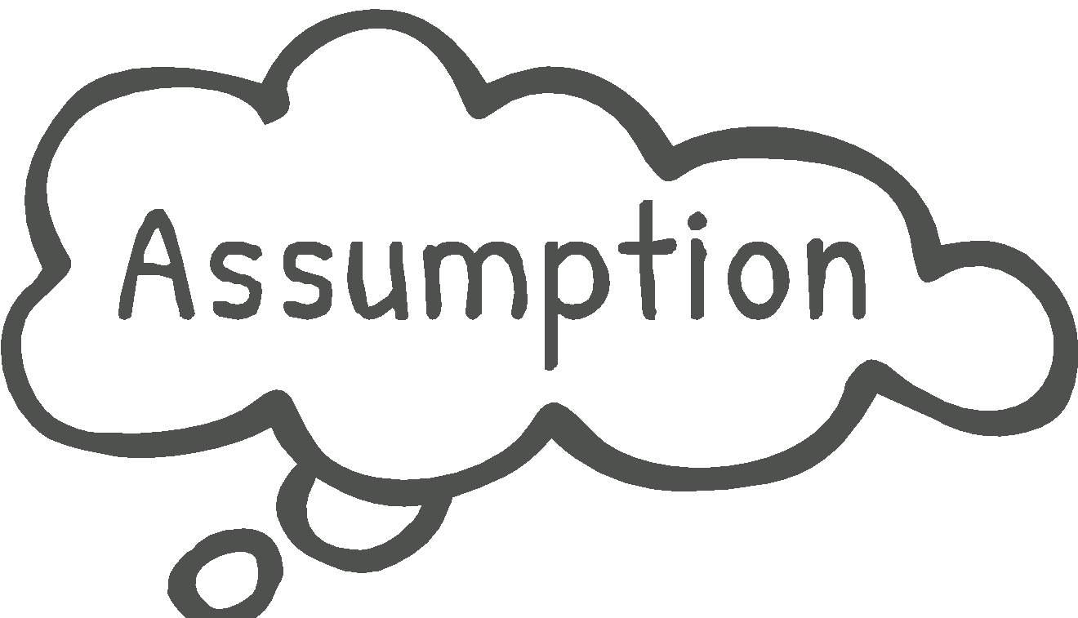

**Risks**: Once you have internalized the role that assumptions play in your theory of change, you will need to assess the risks involved as well.[20] Working in a conflict zone can often pose danger for participants, whether physically, socio-economically, politically, or psychologically. Even a program that produces impact can often have mishaps or casualties. 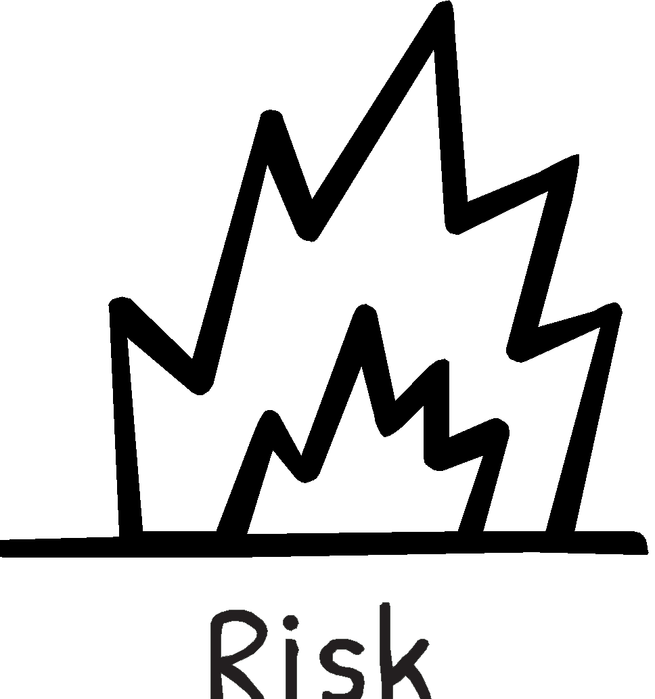

As you map out your organizational risks, consider the different types and how to manage them (see DFID, 2002):[21]

* Risks caused by poor planning or improper management within your organization, that are ostensibly under**** your control and your internal stakeholders.
* Risks caused by problematic policies, lack of resources or institutional weakness across sectors, that can be controlled by key decision-makers and external stakeholders.
* Risks caused by political instability or volatility, such as natural disasters, pandemic and war, that are considered in many ways as uncontrollable.

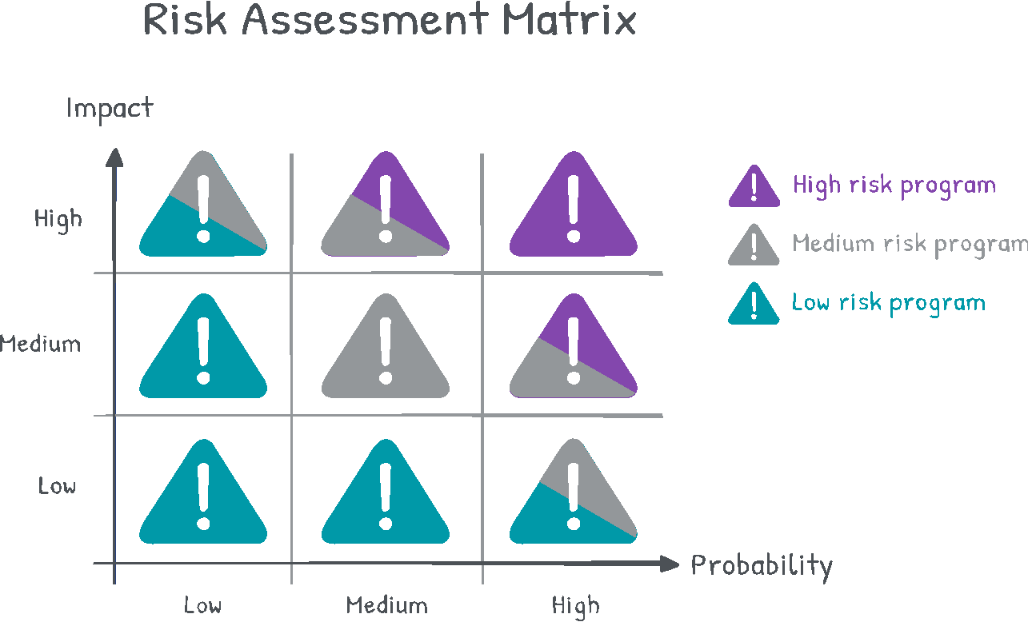

 Risk Assessment - Worksheet

Fill in the chart below with assumptions and risks for your organization or a specific project. This will help you to consider questions such as:

* Have we challenged our current assumptions, and considered different possible outcomes?
* Are we able to understand and anticipate what may possibly go wrong and adapt as needed?
* Is there anything that might prevent us from carrying out our planned activities based on the resources we have allocated?
* Is it probable that the resources invested in our project will lead to our desired outcomes?



|  |  |  |
| --- | --- | --- |
| **Impact** | | |
| **High** |  |  | |  |  |  |
| **Medium** |  | |  |  |  |
| **Low** |  | |  |  |  |
|  |  |  | | | | **Probability** |
|  |  | **Low** | | **Medium** | **High** |  |

Reviewing Strategic Planning Tools

Over the past few sections as we discussed elements of strategic thinking, you have determined key issues and addressed topics such as the problem tree, conflict analysis, theory of change, stakeholder mapping and risk assessment. You have likely found yourselves both zooming in and zooming out to gain varied perspectives of your work and how it situates itself in the peacebuilding field.

As you complete the design phase of your project, you should review key components of your overall strategy as articulated in your organizational values, vision and mission statement. Ensuring full alignment with broader organizational goals and the specific programmatic activities is essential.

In developing any type of peacebuilding program, you will want to make sure that you continue to stay in alignment with your underlying values and your organization’s DNA. [22]

Defining Values

All of your efforts are grounded in the **values** that drive your organizational work. You may need to do a check-in of your articulated values, especially as you evolve over time, to ensure that your programmatic activities continue to reflect key organizational priorities. And if you have yet to make explicit the values that underpin who you are and how you function as an organization, you will want to make sure to do so before moving forward.

You can think of values as the principles and beliefs that shape your organization’s culture and priorities. Being explicit about your organizational values will help to ensure that all aspects of your work are a clear reflection of these values. To facilitate a discussion on this, you can ask questions such as:[23]

1. What do we really care about?
2. What beliefs do we consider most important?
3. How do we want to treat each other and our stakeholders?
4. How does the way we operate reflect our values?

Vision

Your organizational **vision** is what the world will look like once you have succeeded in your efforts. And why is a vision statement so important? It helps to ensure that everyone involved in your work - staff, board members, donors, program participants, volunteers and other supporters - are working toward the same shared belief about what is possible.

If you have yet to articulate your vision statement, this is your time to dream big and think of what might be possible. You can consider components that you have outlined up until this point, especially the conflict analysis. Keep in mind that your organizational vision should address the particular aspect of the conflict that your organization focuses on, rather than the entire conflict. There has to be a way to see stepping stones toward incremental change. After all, if every organization listed ‘world peace’ as its overall vision, then every day would feel like a failure.

So whether you are creating a vision statement or reviewing your current one, you will want to make sure to stay targeted in terms of your peacebuilding efforts. Once aspects of the conflict are broken down into manageable parts and addressed one by one, you are better able to focus on specific desired outcomes. Typical vision statements begin with “we envision a reality in which…”

Ask the questions:

* What would the world look like ideally if our problem was solved?
* How will things be different for our target population and broader community if we are able to realize our organizational goals?
* What will be the long-term result if our organizational is able to address the root causes of the core problem we are seeking to impact?

Mission

While a vision statement articulates the kind of future you want to create, your mission statement focuses on what your organization does to work toward that vision. Your mission statement signals what is the unique contribution that your organization is seeking to make and what sets you apart from other like-minded organizations in the field of peacebuilding.

Whether you are reviewing your mission statement or articulating it for the first time, it is important to keep in mind a balance in terms of your organizational scope of activity. Defining your efforts too narrowly in your mission statement may be limiting. Yet, at the same time, you will want to make sure that your mission statement is not too broad or vague. It should help direct you toward the programs and activities that serve your purpose, and away from those that do not.[24]

Much of the work you have carried out in designing your organizational and programmatic strategy is the raw material to continually refine your mission statement. Take a look at your objective tree and see if you can put it together into one or two cohesive sentences. You can also gather all of these insights and begin by completing the sentence “our organization seeks to…”

For more inspiration, you can answer questions such as:

* What role will our organization play in creating that difference?
* What will our organization be known for in three years? Ten years?
* What is our unique added value?
* Will our mission statement spark enthusiasm among our stakeholders and get more people on board?

In the next section, we will continue to build on the organizational and programmatic strategies that you have outlined and present an overview of developing an M&E plan.

   
 Values, Vision, Mission – Worksheet

1. **Start with values**: What are some keywords that keep popping up? What beliefs about how people should be treated are most important to your organization’s stakeholders?
2. **Defining your vision**: Reflecting on your Problem Tree Analysis, your defined long-term outcomes, and your conflict analysis, you can start to write out what the world will look like after you have completed all of your unique achievements that will help lead to a more peaceful reality.
3. **Clarifying your mission:** Describe the role that your organization plays in achieving the vision you outlined above. What is your organization’s unique role, capacity, and target audience by which you hope to achieve that vision?

**Our Mission**

**Our organization seeks to achieve _________________________________________________ ______________________________________________________________________________________________________________________________________________________________________________________________________________________________________________________________________________________________________________________________________________________________**

**Our Vision**

**In our organization, we envision ______________________________________________ ________________________________________________________________________________________________________________________________________________________________________________________________________________________________________________________________________________________**

**__________________________________________________________**

**Our Values**

**- - -**

**- - -**

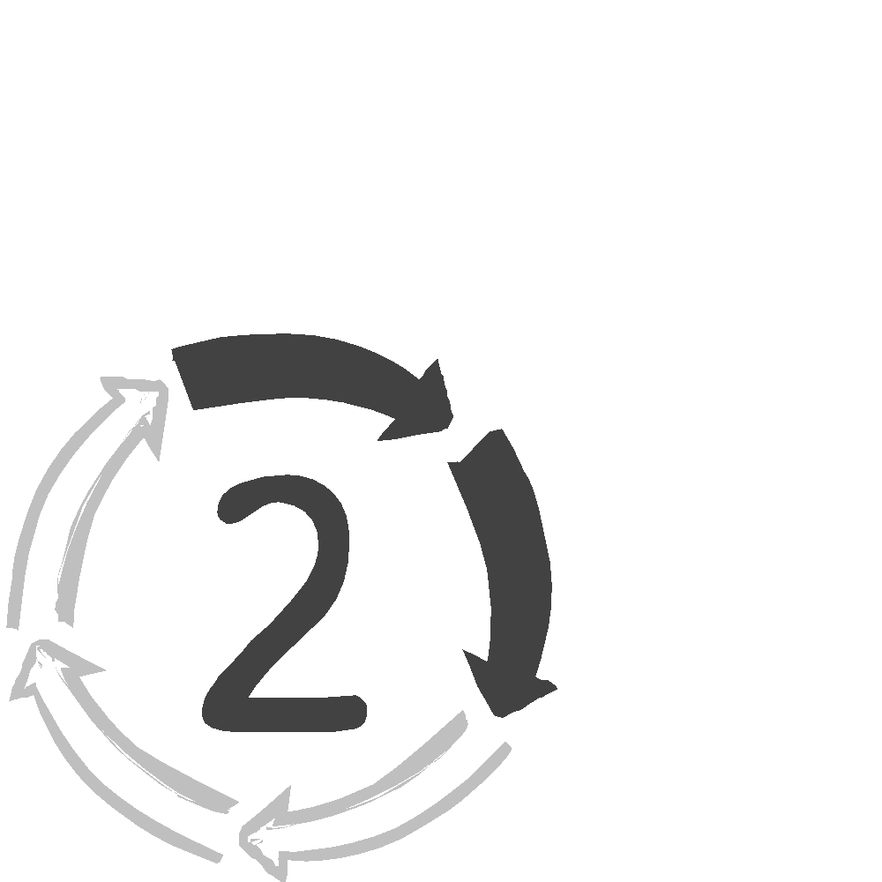Section 2: Building an M&E Plan

Developing a strategic plan that includes a detailed **monitoring and evaluation** (M&E) plan will help your team better plan projects, set expectations, coordinate roles and responsibilities and gain feedback on your peacebuilding efforts. Knowledge and insights gained will then impact your decision-making moving forward.[25]

In this section, we will present the key steps to building an M&E plan, which will enable your organization to set up a feedback loop – a key component of a learning cycle.

*This section is a concise introduction of the M&E process. For a much more detailed outline, see our full M&E guidebook available for download at [www.amal-tikva.org/resources](http://www.amal-tikva.org/resources). And for more practical case studies used in the peacebuilding field, see [www.amal-tikva.org/resources](http://www.amal-tikva.org/resources)*.*

Key components of an M&E plan

While there is a great deal of variation, most M&E plans contain the following steps in some form:

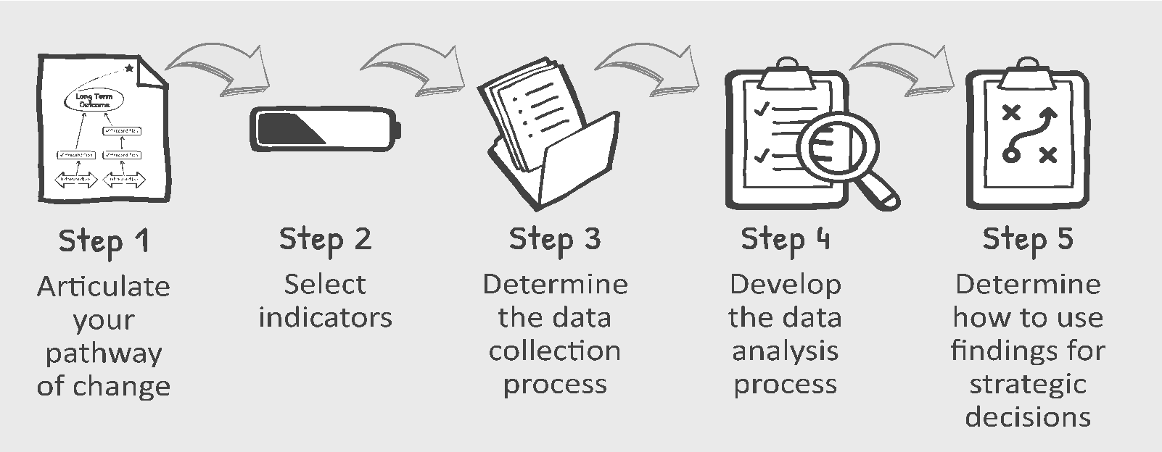

Together, these five steps indicate how you intend to collect, manage, analyze and use data for both monitoring and evaluation processes.

Monitoring is ongoing. Collecting data - daily, weekly or monthly - in order to use that information for the day-to-day management of your work. It is a capacity that we develop within organizations to track progress and make informed decisions.[26]

Evaluation takes a more comprehensive assessment of your work over a period of time. Evaluation will often involve helping you to understand how to mark progress toward stated goals and assessing how and what has been accomplished.

|  |  |  |  |
| --- | --- | --- | --- |
|  | **How often do we  gather data?** | **What kinds of data are we hoping to collect?** | **Who is responsible for carrying out the process?** |
| **Monitoring** | Regular intervals: daily, weekly, or monthly. | Data about activities, expenses and short-term outcomes. Tracking project performance. | Members of your team who are involved with  the project. |
| **Evaluation** | Usually at specific times. May be halfway through, or at the end of the project, depending on  the evaluation purpose. | Data about intermediary outcomes and long-term outcomes. | An internal or external team of evaluators, or a combination. |

The first step in any M&E process will be to build on the strategic processes outlined in Section 1, enabling you to articulate a theory of change in your peacebuilding efforts.



Step 1: Articulate Your Theory of Change

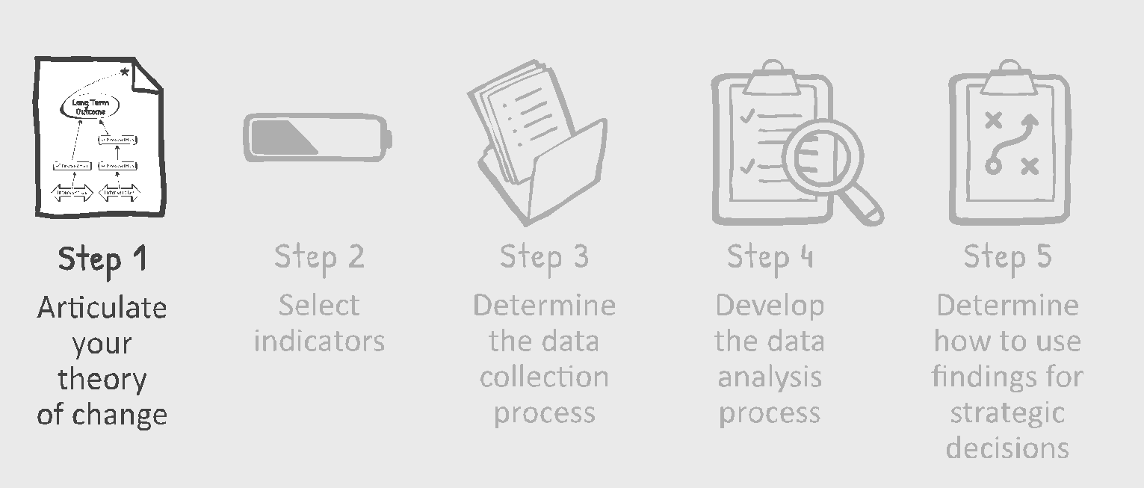

Your M&E plan is a set of tools that will help you measure progress toward a desired impact that is reflective of your organizational priorities. To ease into an M&E plan, we want to introduce two well-known project design tools that will unpack your theory of change: the ‘pathway to change’ and the ‘logical framework’ also referred to as ‘logframe’ or ‘logic model’.[27]

Each of these techniques offers a visual representation of what you are trying to achieve, thereby enabling you to clearly outline and communicate the underlying logic of your efforts in the field of peacebuilding.[28]

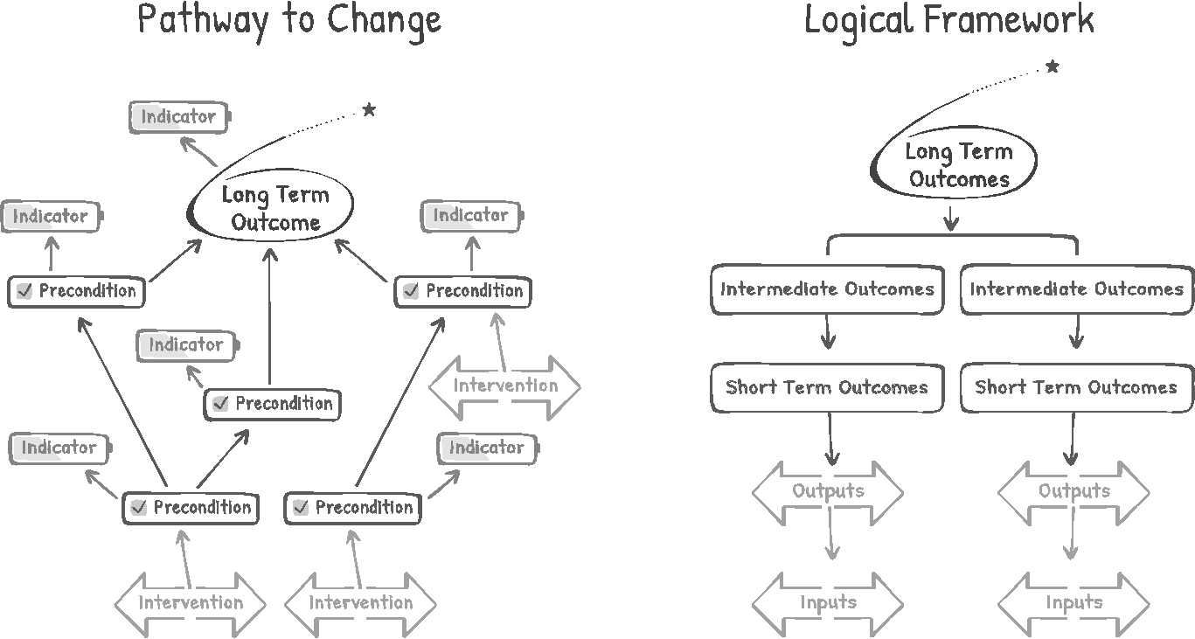

A Pathway to Change

A pathway to change diagram is one of the most recognizable components of a theory of change process.[29] It is a tool to help illustrate how your efforts in the field can lead to desired impact.

You can review the articulated long-term outcomes derived from your objective tree during the design phase. If you recall, these outcomes were originally identified from the problem tree, and then prioritized in the conflict analysis. In your theory of change, you show how you are tackling them one by one. This way, when you add new activities (otherwise known as interventions), you see how each of your projects directly contributes to achieving your desired long-term outcome.

A logical framework, presented below, is another popular planning tool to articulate your theory of change and it will help in creating a shared understanding of what you are hoping to achieve through your peacebuilding efforts.

Outlining the elements of your Logical Framework

**Step 1: Long-term Outcomes – what you hope to achieve over time**

Just like in the pathway to change, the logical framework begins with the long-term outcomes derived from your objective tree in the planning phase. Often this is referred to as the ‘purpose’ or ‘overall goal’ or ‘vision’ because it reflects what society will look like once your organization has succeeded in fulfilling its mission. You can recall that these outcomes were translated originally from the root causes in your problem analysis, and subsequently, these outcomes were prioritized in your conflict analysis.

**Step 2: Define Short Term and Intermediate Outcomes - how you get there**

The next step is to outline the preconditions, referred to here as your short and intermediate outcomes.[30] You can think of these types of outcomes as a bridge between activities and impact- the stepping stones- that if achieved, will lead to your long-term outcomes. Particular focus is required, especially for organizations working in field of peacebuilding. For example, a desired outcome like ‘regional peace’ or ‘a complete cessation of violence’ may be too general to take on. It is more likely that you will want to tackle a specific, conquerable element of the context that will contribute toward a broader peace.

**Step 3: Define Activities - what are you actually doing to make it happen**

And now that you have set your intended results, you are ready to design your project’s activities or review existing activities to align with your theory of change. In the logical framework, activities are made up of the inputs and outputs.[31] Inputs are what gets put into your project – your financial resources, rented space, expertise of your team, etc. Outputs are what you plan to do- build houses, offer loans, provide workshops, etc. The logic model will then tell the story of your theory of change as outlined below. If you implement the inputs and outputs while taking both assumptions and risks into account, it is more likely that you will be able to achieve your desired outcomes.

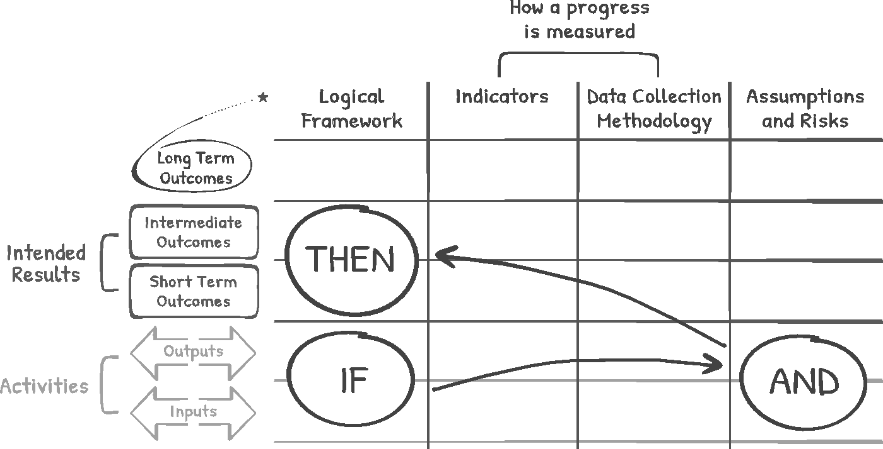

**Note the difference between outputs and outcomes.** For example, you may specify in your logical framework that your planned output is a training workshop. Yet the implementation of the workshop, the output, does not necessarily guarantee that your desired outcome - new skills for your participants- is achieved. To assess you are reaching your desired impact, you will need to differentiate between tracking outputs - the implementation of your activities - versus tracking actual outcomes. A clearly articulated logical framework that is part of your M&E plan will enhance your ability to do so.

Assumptions and Risks

As previously discussed, **assumptions** are grounded in your **beliefs, biases, opinions and experience**. And they can also, hopefully, be evidence- based. **Risks**, alternatively, include everything we need to **keep in mind that may disrupt your plans or be harmed by your programs.**

By identifying potential risks, you can think of solutions to avoid these risks or be prepared when new challenges arise. This will ensure that your interventions are conflict-sensitive and do not result in a negative impact (also known as your do-no-harm approach). **For each part of your inputs, outputs, short, intermediate and long-term outcomes- you can ask these questions:**[32]

* What could go wrong?
* Is there anything that might prevent us from carrying out our planned activities based on the inputs we have allocated?
* Is it probable that the inputs invested in our project will lead to our projected outputs?
* What is the likelihood that our planned activities (inputs and outputs) will over time, result in the desired long-term outcomes?

The risk assessment matrix, as discussed previously, can help guide you in identifying risks and potential solutions associated with your activities. This understanding should help you to create more informed, effective and well-structured interventions.

Ongoing strategic alignment

With your strategic priorities articulated in a theory of change, it will be important to continually check alignment in all aspects of your work. As you develop a detailed M&E plan, you can assess current programs in order to review and clarify strategies before moving forward.

 Program Activities – Worksheet

To assess the current programs of your organization and the degree of strategic alignment,   
 you can review the following chart.*

|  |  |  |  |  |
| --- | --- | --- | --- | --- |
| **Program title** | **Objective - directly from objective tree** | **Fit in with theory of change?** | **Relevant preconditions** | **Relevant  long-term result** |
|  |  |  |  |  |
|  |  |  |  |  |
|  |  |  |  |  |
|  |  |  |  |  |
|  |  |  |  |  |

Now, take a look at the table and ask yourself:

* Do all of our activities fit in with our theory of change?
* Are there programs that we spend resources on that do not contribute directly to our preconditions or overall objectives?
* Did we miss some preconditions and long-term outcomes in our theory of change that we need to add?



* This is the time to critically evaluate each program's relevance and discuss whether programs that do not fit with your theory of change should really be run through your organization at all.

Step 2: Select Indicators

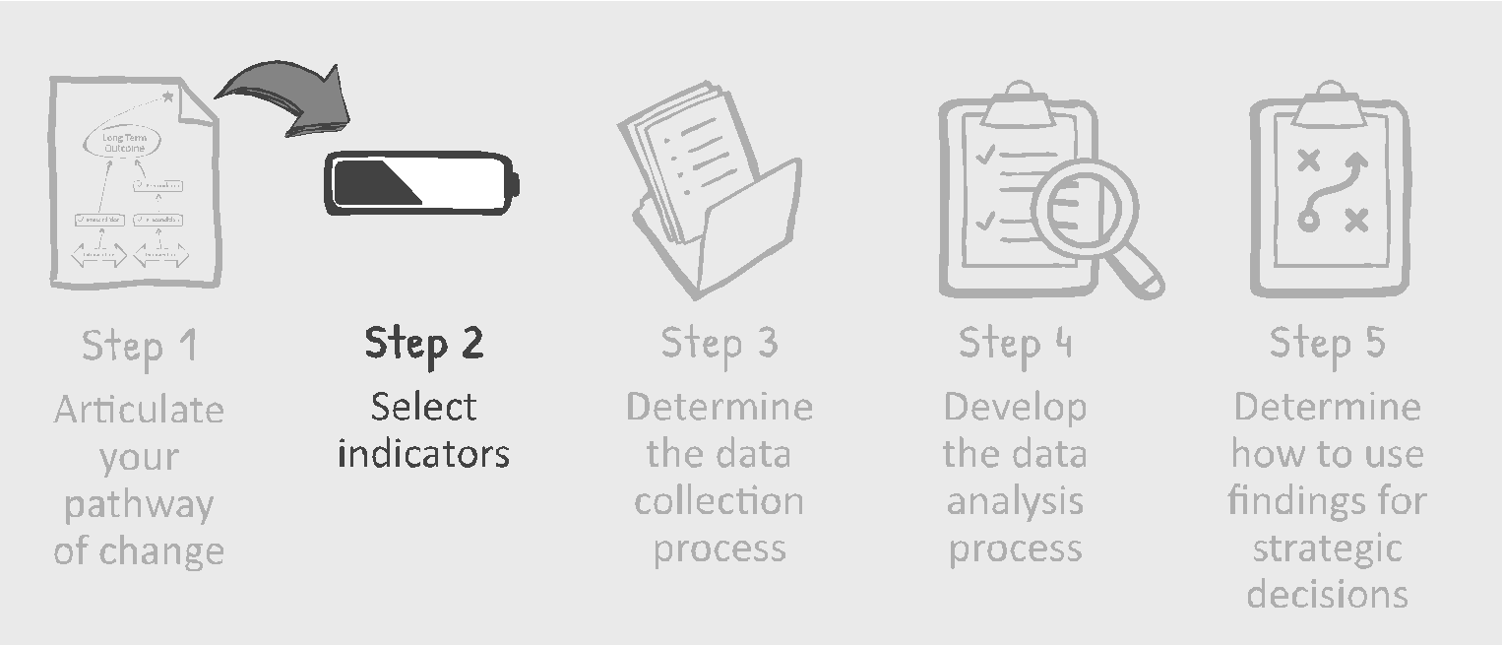

It is important to **think about *why* and *how* change has happened, and how important this change is to those affected by your efforts.**[33] An indicator is the information that tells you whether or not your program is achieving its intended outcomes in the complex field of peacebuilding.

While often quantified by specific measures, indicators can take many different forms. ‘Dashboard indicators,’ a common term used in the field, can provide us with an overall picture of the most important information that we need to know for M&E processes.[34] Your indicator, simply put, is your ‘evidence’ of change.[35] You can select a variety of indicators to *indicate* that some type of change has occurred.

Quantitative vs. Qualitative Indicators[36]

|  |  |
| --- | --- |
| **Quantitative data**  Answers questions such as:   * To what extent has a change taken place? * To what extent have our targets  been met?   Expressed in numerical terms, counted, or  compared on a scale. Includes survey data,  attendance numbers, and test scores.    **Quantitative indicators**  Measures in numerical terms- numbers,  percentage or ratio.  Helps to assess if projects are on track. | Qualitative data  Answers questions such as:   * Why has there been a change? * Why has this change occurred? * How has this change occurred?   Usually presented in a narrative format  Includes information collected from observations, focus groups, or interviews.      **Qualitative indicators**  Measures what people think, feel or believe.  Helps us to assess how and why change has occurred. |

Linking indicators to your logical framework

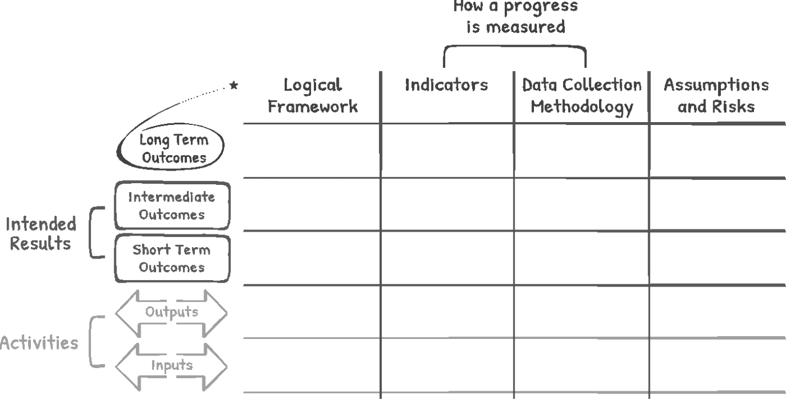The M&E template presented below can be used to demonstrate the link between the various key elements of your peacebuilding efforts. Indicators, as based on your logical framework, will help measure how well you are providing inputs, creating outputs and bringing about short, intermediate, and long-term outcomes.

In general, indicators that measure inputs and outputs will help you with monitoring the implementation of your planned work.

We often call these kinds of indicators **-** process indicators**[37]** which tell about activities such as- if services are being delivered, if participants are showing up, or if staff are being trained as needed. Tracking this kind of information is a critical piece of your M&E plan - you just have to define it first.

|  |  |  |  |
| --- | --- | --- | --- |
| Process indicators- monitor the implementation of the activity - relating to inputs and outputs.   |  |  |  | | --- | --- | --- | | Process indicators related  to **input** include:  financial resources, human resources, administrative resources, equipment required. |  | Process indicators affiliated with **outputs** can include:  # of participants, % of the target population participating in the program, % of the participants who attend or are involved, the dropout rate, # of key stakeholders engaged.  Process indicators can also consider participant satisfaction such as:  Do participants feel comfortable?  Are the staff approachable?  Is the venue set-up appropriately?  Is the project activity run at convenient times?  Do the topics covered meet the project’s purposes?  Are the topics taught in an engaging way?  Process indicators also assess implementation through indicators such as:  # of workshops conducted,  # of activities implemented,  # of materials distributed,  If materials were easy to comprehend, If materials used were appropriate for the audience, etc. | |

Indicators that measure the various types of outcomes, as outlined in your logical framework, are called **outcome indicators** or alternatively, **impact indicators**.[38] These outcomes are especially important in **understanding the progress of your project toward its desired results**. In exploring the longer-term effects of your peacebuilding work, these types of outcomes often include a range of topics such as behavior modification, attitude change, health status and quality of life.



Outcome Indicatorsmonitor intended results relating to short-term and long-term outcomes.

|  |  |  |
| --- | --- | --- |
| **Short term outcome indicators** monitor your project’s progress. This usually relates to short-term change such as:   * Awareness, knowledge and skills * Individual capacity, i.e., confidence, self-esteem, social skills, problem solving skills, increased help-seeking behavior, coping skills and optimism * Increased social networks |  | **Intermediate / long-term outcome indicators**, also known as impact indicators, are used to assess if the project’s goal has been achieved by measuring for example:   * Increased mental/physical well being * Community engagement * Increased education * Increased employment |

SMART and SPICED Indicators[39]

So while there are no set rules in choosing indicators, there are guidelines that are useful in the selection process. A common framework that is used is the ‘SMART’ framework which helps to keep particular characteristics in mind when setting quantitative indicators.



**Specific** - From the way the indicator is phrased, is it clear what exactly will be achieved? Did you consider disaggregating your data to make it more informative?



**Measurable** - Are you sure that it is possible to collect data for such an indicator? Do you have the expertise, time and staff to collect the required data?



**Achievable** - Is it realistic to expect the indicator’s targets to be achieved with the time, staff and funding you have?



**Relevant** - Does the indicator capture the change described in your inputs, outputs, and outcomes?

**Time-bound** - Is it clearly specified by when the indicator will be achieved?

Another acronym that is especially useful while engaging in a participatory approach to M&E is the ‘SPICED’ approach, which draws heavily on qualitative and descriptive measures. This approach encourages much more involvement of stakeholders to define the indicators of your peacebuilding efforts and therefore, requires more time and resources to facilitate.

**Subjective** - Are the indicators subjective-with the ability to capture an individual’s unique insights (i.e., where the 'anecdotal' becomes critical data because of the source’s value)?

**Participatory** - Are the indicators developed together with those persons best able to assess them (i.e., members of target community, project team)? 



**Interpreted and communicable** - Do the indicators hold meaning, and can their rationale be easily explained to other stakeholders?



**Cross-checked and compared** - Are the varying indicators and measures of progress cross-checked by using different informants, methods, and researchers?

**Empowering** - Has the process of setting and assessing indicators helped to empower members of the target community to carefully reflect on desired changes? 



**Diverse and disaggregated -** Has there been an effort to seek out specific indicators from different groups, including men and women separately? In addition to the need for gender disaggregated data, is there a way to analyze data on other important differences such as age or educational level?

Step 3: Determine the data collection process

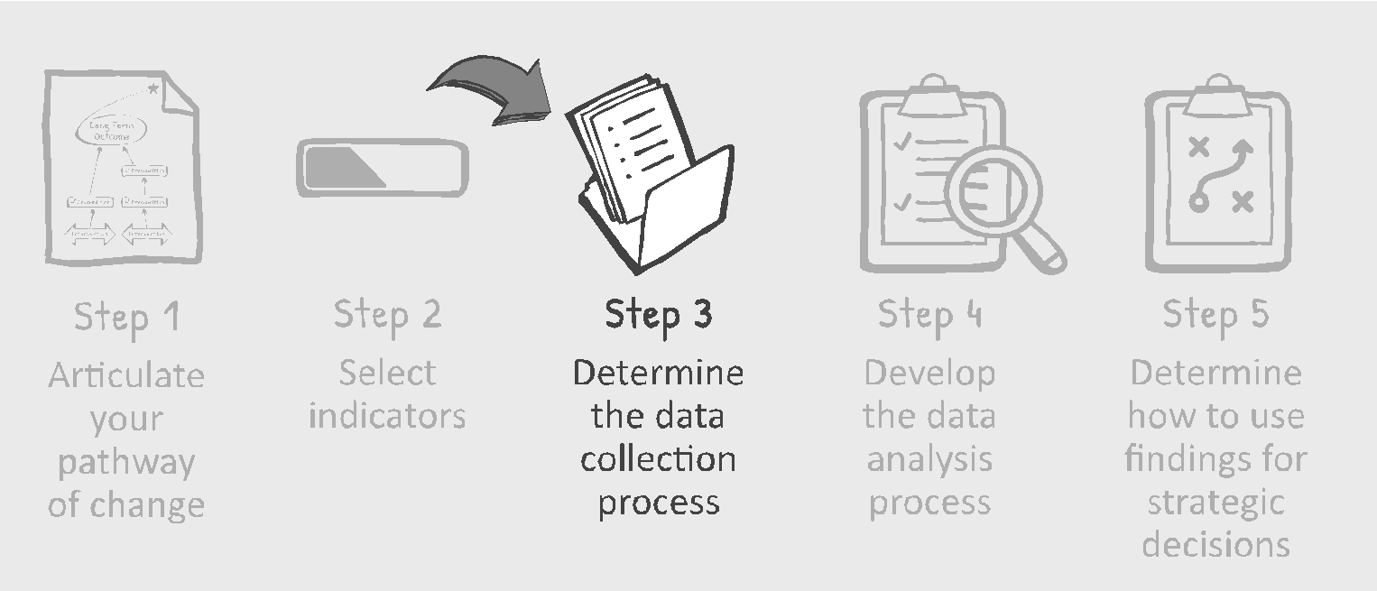

Having addressed the logical framework, indicators, assumptions and risks, we will now focus in the next section on data collection methodology. The data collection and data analysis tools that we will be reviewing are often referred to as research methods.[40] In carrying out M&E, your focus is on ‘practice’, with much less emphasis on ‘theory’. You are not setting out to make a theoretical contribution to the peacebuilding field which you tend to do in research studies.[41] Instead, in your M&E efforts, you use research methods to collect meaningful data as part of a feedback loop for learning which will ultimately enable you to improve your work and enhance the chances of making a long-term impact.

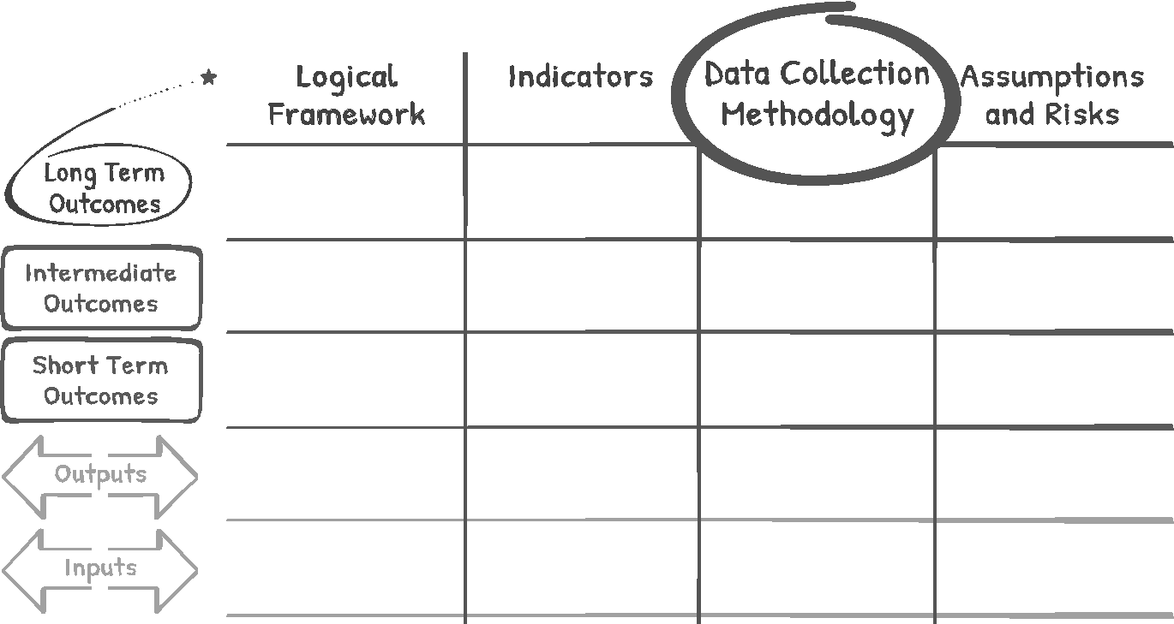

**Data collection methods used for M&E:**

**Interviews**

Individual interviews achieve a greater understanding of how your work is experienced by individuals who are affected by your programs. One on one conversations, usually conducted with a list of prepared questions, can be done face-to-face, by telephone or by video.[42] Interviews can be in-depth, semi-structured or totally unstructured depending on the information being sought.[43] Talking to people is an especially useful data collection instrument when you are interested in an individual’s perceptions, opinions, ideas, experiences and, of course, stories. Interviews provide rich information with the opportunity for follow up for clarification. Be sure to be aware of active-listening skills, language needs, and cultural sensitivities and gender dynamics.

**Document Review**

Documentation that you develop for your project can provide an ongoing record of activities,[44] such as budgets, intake forms, sign-up sheets, organizational policies, attendance sheets, work plans, as well as existing records from external sources (also referred to as secondary data sources) can also be valuable.[45] This can also include informal feedback and/or reflections through journals, diaries or progress reports. Be careful about participant privacy, data quality and security.

**Observations** 

Observations that are directly seen or captured on visuals such as through photographs and videotapes, provide insight into what is actually happening in the field,[46] including everything from physical surroundings and ongoing activities to the behavior of individuals and their interactions.[47] Generally, it is helpful for observers to be equipped with an observation guide that serves as a checklist which provides more uniformity in the data collection process. Collected data is based on actual behavior that is observed in real time (in contrast to self-reported behavior that is recorded either in interviews or in questionnaires) and is generally non-intrusive and does not require active participation of program participants.[48] Observations require sensitivity so as not to affect or disturb those under observation or elicit bias.

**Participatory Community Mapping** 

As a collective approach to data collection, community mapping can help you build a shared understanding by presenting a snapshot of how members of a community currently perceive the present situation.[49] Community mapping can be useful, for example, in the identification of infrastructure and basic services, in identifying existing resources and in helping to establish a baseline for data collection.[50] It is a participatory process that affords opportunities for group discussion and for building a rapport among participants.[51]

**Creative Tools**

Various creative approaches provide an alternative to the written word, such as creating a play, an exhibition or a video. Creative tools often enable participants to reveal insights that they may not have been able to articulate otherwise, offering a distinct opportunity for self- expression. An arts-based approach can provide data which could then be used to supplement and enrich more traditional data,although someindividuals may not feel comfortable if, for example, they are not inclined to engage with art. A lack of familiarity with less-conventional tools may lead to skepticism and even awkwardness depending on the context. It is important to have a clear rationale for the selected approach defined in advance.

Here are some examples:

* **Storytelling.** Through writing and performance (play and/or dance), storytelling can be used as a way to capture the personal and/or group experience.
* **Dance and drama.** Each of these methods can offer insights into how individuals interpret their experience which can then be shared with a broader audience.
* **Impact Drawings.** Illustrations can portray past, present or future situations, and can be especially useful for encouraging reflection and showing change.
* **Other Examples** of self-expression include photo essays and collages.

**Surveys** 

Questionnaires, as a very common M&E tool, are helpful in gathering four types of information about individuals: 1. Knowledge 2. Beliefs/ Attitudes/Opinions 3. Behavior and 4. Attributes.[52] Survey questions come in various forms, including closed questions, open-ended and scaled questions, and multiple-choice questions.[53] Closed questions are usually in the format of yes/no or true/false options. Open-ended questions, on the other hand, leave the answer entirely up to the respondent and often provide a greater range of responses.[54] Surveys which can be administered online, by mail or in person, are practical for gathering a large amount of data and thereby in providing a broad perspective. If the same set of questions is asked at the beginning (for baseline information), and/or at various intervals during and after your program is completed, surveys can be useful in tracking change over time.

Questionnaires can be anonymous, allowing respondents to therefore be more inclined to honestly share their true feelings. However, careful attention must be given to the design of the survey as biased and leading questions can skew results. Pilot testing the survey on a sample of your target group is essential.

**Focus Groups**

Group interviews, or focus groups, give you an opportunity to talk to a number of people in a relatively short period of time. In focus groups, a small number of people, usually 6-12 individuals, are brought together to discuss specific topics under the guidance of a facilitator.[55] Equipped with a prepared set of interview questions, the facilitator leads the discussion. Participants are encouraged to freely express their views and engage in a dialogue with each other which often results in meaningful insights and perspectives.

The group setting lends itself to examining complex issues and for gaining deeper, collective insights. A group context provides an alternative for those who are less inclined to engage in one-on-one interviews or take the time to fill out a written survey. A focus group can also be added on to an existing program so that additional resources do not need to be expended on M&E and participation rates will be much higher. Skilled facilitation is especially required to create an inviting environment, deal with possible conflict, ensure a balanced discussion among all participants, and mitigate the possibility of ‘groupthink’ or overpowering individual participants.

* As you begin to select your methodology… 

In selecting your own data collection methodology, it is essential to consider your specific context, needs, indicators, and capacities. Reflect on your capacities, what you most want to learn, and your context.[56] Because M&E is so critical to your success, it must be integrated into your work in a way that is manageable. Consider building a plan that fits in with your team’s capacity as well as your desired outputs. Take a look at “the fit” below.

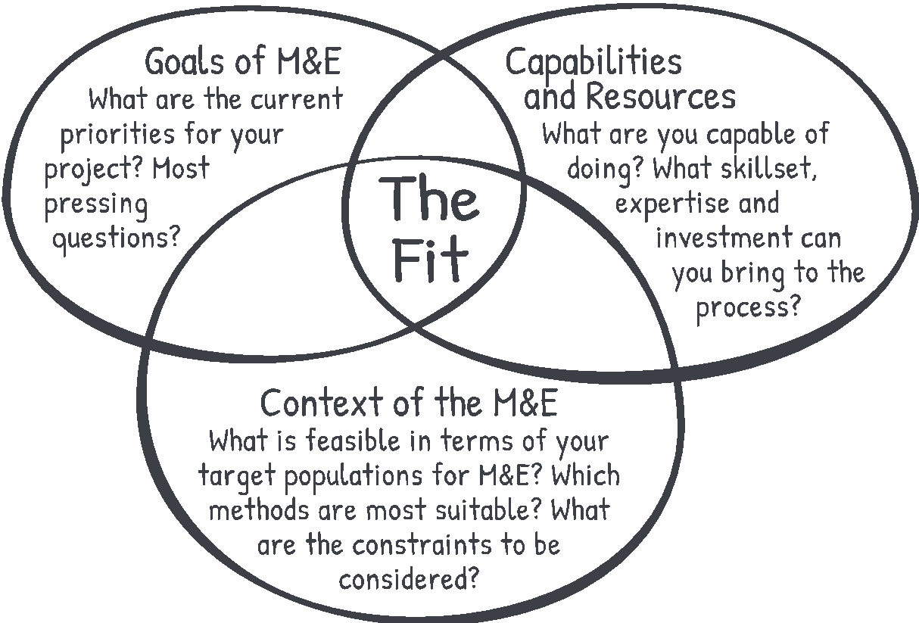

Selecting a data collection method

When you are determining which methods to use and developing your data collection plan for M&E, ask yourself the following questions:

|  |  |  |  |
| --- | --- | --- | --- |
|  | **First ask…** | | **And then ask…** |
| What Data? | What kind of data will we need in order to measure our indicators? | Will the selected data collection method(s) provide the correct type of information? | |
| From whom? | Who are the individuals who can provide the needed data? | Are these selected data collection methods appropriate for the groups of people from whom we would like to collect data?  For example, would your respondents be willing to fill out complex, written tools? Or would they prefer in-person conversation?  Do you need to collect data from a large number of individuals in various locations or would reaching a few key individuals suffice? Or for example, if you are running a youth program, should you also be eliciting feedback from the parents and teachers of your participants as well as the youth themselves? | |
| **How often?** | How often do we need to collect these data? | Will we be able to use these data collection methods as often as we need to? | |
| **By whom?** | Who will be collecting the data? Who will be carrying out the data analysis? | Are they qualified to use these selected data collection methods and the subsequent data analysis?  Who is available with the experience in group facilitation or research methods? Do they speak the same language as the individuals they will be communicating with, or will we need to translate tools and guides into different languages? | |
| **Is it a possibility?** | Will these data collection tools be practical to use? | Do we have the time, expertise and resources needed to use these data collection methods? Are we able to properly address any ethical concerns or issues of confidentiality? | |

Of the many considerations that will influence data collection methods, one to particularly note is whether the data you are collecting is especially personal and therefore should be conveyed in a confidential manner. Group settings for data collection in a focus group for example, may be too public a forum if you would like to collect particularly sensitive information. In this type of context, the use of questionnaires with the built- in option of reporting on perspectives in an anonymous fashion, might be more suitable.

Pay attention to ethical concerns in your data collection: 

Carefully consider the past experiences of individuals from whom you are collecting data. Remember the broader context and make sure that your data collection efforts do not cause any worry or discomfort to members of your target community or to others.

For example, check that you are not creating a stressful or confusing experience that takes up too much time or causes hardship in some way. You will need to check that participants give their informed consent to collect and use their data, and that they understand exactly what they are agreeing to. And of course, when necessary, ensure that participant data is kept anonymous and confidential.[57]

Tailor your data collection tools to your own context:

Before you design a data collection tool, assess the cultural context, especially with regard to language, technology, and literacy. Similarly, you will also want to consider culturally preferred methods of communication (i.e., comfort level talking to strangers, appropriateness of a person of one gender interviewing a person of another gender).

Explore the option of sampling:

Depending on your specific M&E plan, you may need to incorporate an appropriate sampling method. If you are only working with a small group of individuals, then you probably will not have to use sampling. However, with larger projects, you will likely gather data from a sample of the group.[58]

Perhaps you have volunteers who would like to become involved in a different aspect of your organization, or a board member who would enjoy gaining firsthand knowledge of your programs. Maybe there are students who are interested in internships and looking for opportunities in applied research? Keep in mind that it may be inappropriate or even unethical in certain circumstances to involve those outside of your team when sensitive or confidential information is being shared or when the strictest privacy standards are required.



**Logical Framework - Worksheet**This worksheet enables you to consider how all the elements fit into the design of an M&E template called the Logical Framework.

First consider your logical framework and selected indicators. Then choose a data collection method for each of the indicators listed. You can measure several indicators with the same tool as long as those indicators have the same data collection method, source, and frequency of collection. You can group indicators together to reduce or eliminate unnecessary data collection efforts.

Here are some tips to keep in mind regarding the data collection process:

* Carefully consider who will be using the tool and how.
* Make sure that your team is trained and has instructions/ guidance as needed.
* Pre-test your tool, pilot test everything!
* Stay focused on gathering only the essential information.
* Keep track of the details of data collection (who, what, when, where).



|  |  |  |  |  |  |
| --- | --- | --- | --- | --- | --- |
|  |  |  |  | |  |
|  | | Logical Framework | Indicators | Data Collection Methodology | Assumptions  and Risks |
|  |  |  |  |
|  | |  |  |  |  |
|  |  |  |  |
|  | |  |  |  |  |
|  |  |  |  |

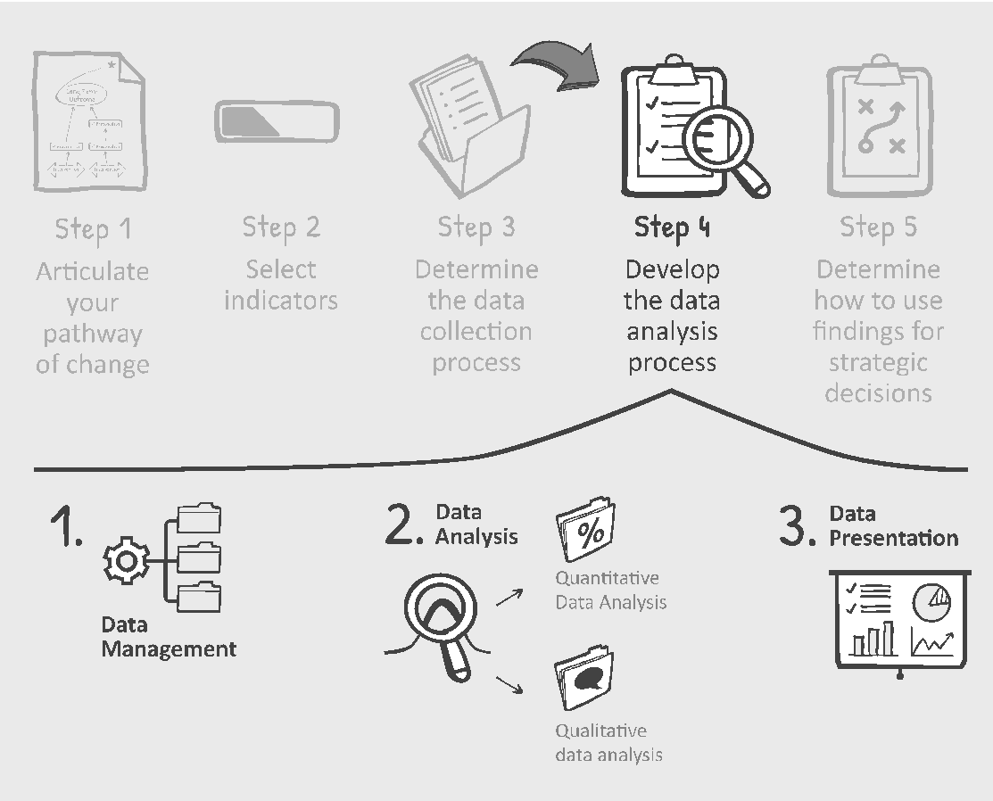Step 4: Determine the data analysis process

At this stage, you suddenly find yourself inundated with different kinds of data. It is critical to consider how to manage, analyze and present data in a way that eventually enables you to learn and improve your work which is of course, the goal of our M&E process.

**DEFINITION OF TERMS[59]**

**Data Management**

Data Management is a system of how your data is stored in an organized and secure manner and who will be given access to it. With all your variety of data (possible audio recordings, videos, completed questionnaires, photos, etc.), your team should follow a few rules for data formatting and storage, record those rules in a single document and share with anyone who manages data. 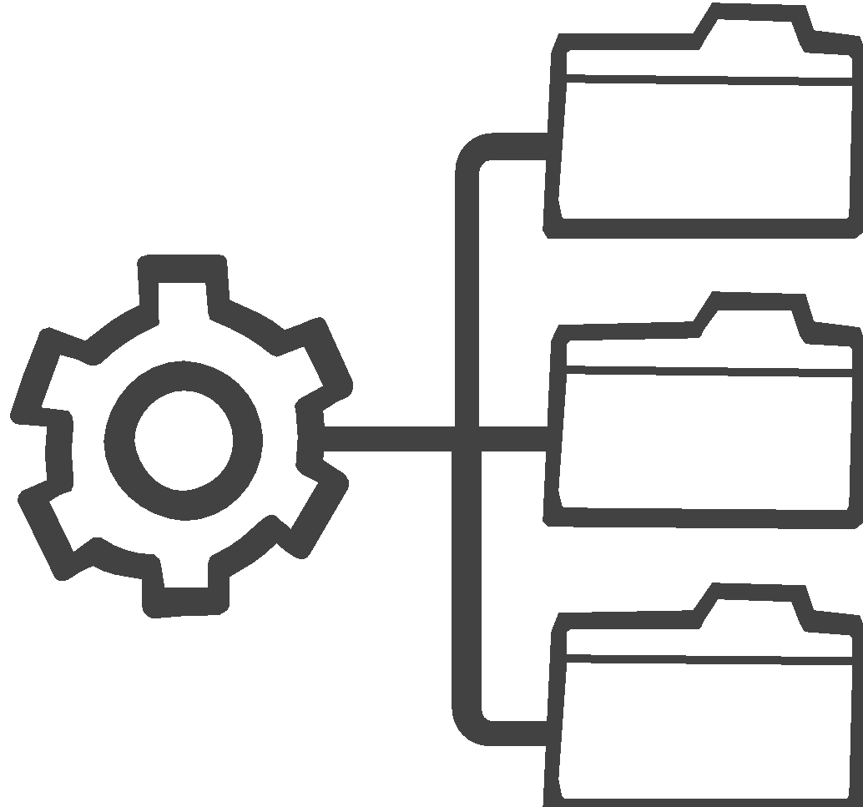

**

The term ‘data analysis’ refers to the process and the tools for interpreting data. Data Analysis gives your data meaning - interpreting and placing it into a context in order to inform the decision-making process.



 **Assuring Data Quality**

Keep in mind a number of considerations

* Are you collecting valid data that measures what you want and only what you want?
* Is your data reliable and of the same quality over time?
* Is your data up-to-date and complete?
* Is confidentiality protected?
* Does your data have enough different details to present a fair picture?
* Is your data accurate and error-free? As you can imagine, if your data is full of errors, inaccurate or incomplete, the information you collect will not be useful for either your   
  analyses or decisions.

|  |
| --- |
| **Steps of Data Analysis**  Data analysis generally includes the following process: coding your data, analyzing, interpreting and reflecting. With all the kinds of data you will gather, consider the following: |
| * What do these findings mean? What can you learn from them? * What conclusions can you draw? What are some other interpretations of these findings? * Are any of these findings surprising? What do these findings confirm? * What are the limitations of our analysis? * What are some of the possible implications of these findings?[60]   In general, your data analysis begins by first reviewing your M&E questions and indicators. You will then sort the data pertaining to each question by type, either quantitative and/or qualitative, and ‘clean’ the data to eliminate any incomplete or incorrect data. Depending on what you want to know and the type of data you have collected, you should then determine the appropriate type of analysis. |

Quantitative Data Analysis

Quantitative data analysis interprets data that can easily be counted, measured and expressed with numbers. Sources of quantitative data include surveys, sign-in sheets, health and demographic data, census data and budget data.[61]

Quantitative data analysis can consist of simple calculations yielding information on topics such as attendance, usage, changes in performance, or changes in knowledge (e.g., pre- and post-tests). Some examples of commonly used descriptive statistics include: frequencies (numbers, a count of how many), percent (proportion) distributions, means (average), medians (mid-point), and modes (the most frequent value). Analysis can be done with the help of spreadsheet software (e.g., Excel).  
  
**Qualitative Data Analysis**

Qualitative data requires much more flexibility and effort during the process of data interpretation.[62] The sources of qualitative data include text, images, and narrative (e.g., interview notes, unstructured observations, open-ended questionnaires, focus group transcripts), and visual data such as photographs and film/video). As such, analysis techniques are based on reflection, categorization and interpretation.[63]

Qualitative data are especially useful when you are looking for a description of a program, process, or experience or if you would like to understand the context of a situation and/or understand perceptions.[64] For qualitative data analysis, it is highly recommended that you have more than one person do the ‘coding’ or ‘categorizing’ and that those entering the coded data are from outside the organization to help ensure impartiality. Bringing additional perspectives to the analysis can offer valuable insights and help control bias in analyzing qualitative data.

**Engaging Stakeholders in Data Analysis**

What are some ways to elicit stakeholder input with *quantitative* data? You can start by presenting preliminary data from items such as surveys and charts for their analysis and interpretation.[65] Examples of questions to guide your discussion can include:

* What surprises you about the data?
* What factors may explain some of the trends you are seeing?
* What do these findings confirm? What did you expect to see in this data, but don’t?
* Does this lead you to raise new questions?

What are some ways to elicit stakeholder input with *qualitative* data? Examples of questions to guide discussion include:

* How does this information align with your experience and perceptions?
* What doesn’t fit? How so?
* Are there other interpretations of the data that are missing?
* Where would you add context to clarify or explain the findings?

As data are collected, ask your key stakeholders what is most interesting, illuminating, or important. By doing so, you are creating a process that helps to ensure a rich interpretation of the data over time. Including multiple perspectives in your analysis can allow for a more accurate portrayal of program implementation and impact.

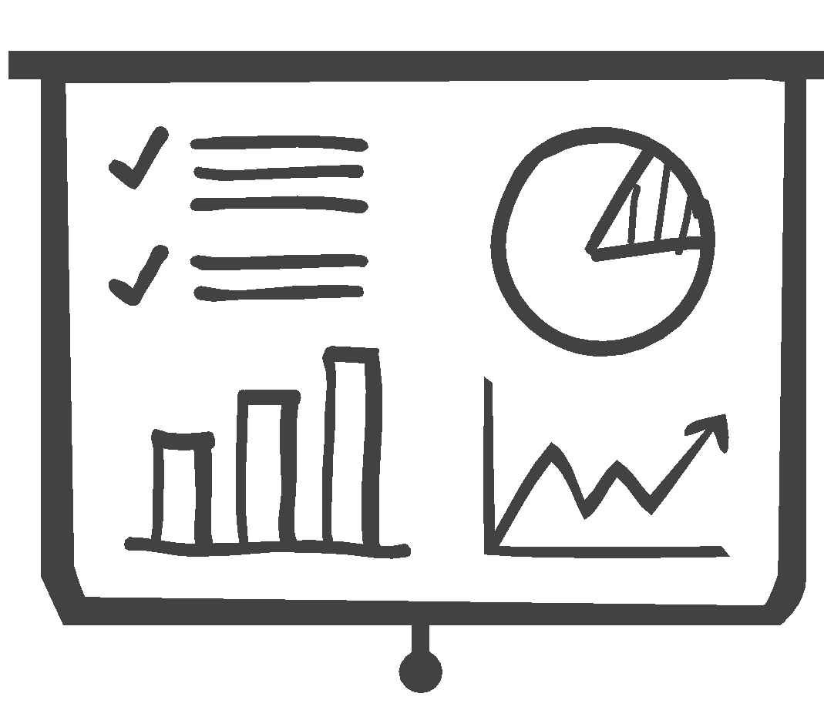

Presenting Data

While we have focused primarily on the *kind* of data that you are organizing and analyzing, we now want to focus on options for *how* you can present your data.

Data presentation is part of what needs to be a broader communication strategy to ensure that your organization manages and disseminates information in a way that promotes shared learning.

Your quantitative and qualitative data each have to be presented in an engaging, distinct way.[66]

|  |  |
| --- | --- |
| **Qualitative Data**   * Text * Images * Narrative | **Quantitative Data**   * Averages * Comparisons * Proportions * Trends |

Graphics can help to simplify the M&E data and clarify the results.[67] You have lots of options in conveying quantitative data like those below:

   

**Tables Bar Graphs** **Pie Charts  Line Graphs**

And certainly, you won’t want to forget possibilities for qualitative data in addition to narrative text   
such as:

  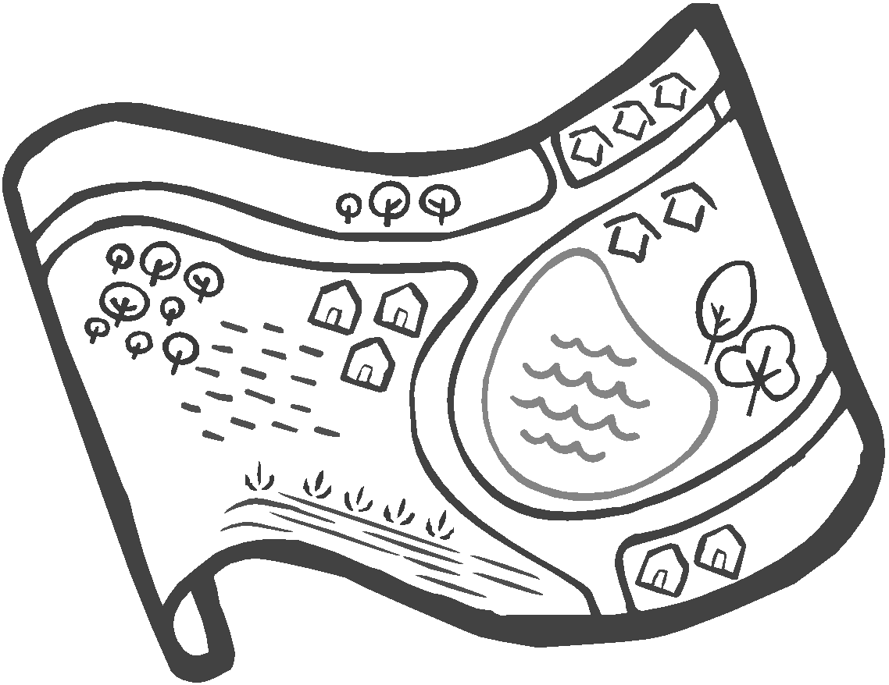

**Photos Videos Community Maps**

In facilitating discussions about the preliminary results of the data, make sure to consider various questions such as:[68]

* What is the best way to communicate with this stakeholder or group of stakeholders?
* Would an in-person/online meeting be the best way to reach them? An email? A written report? A video clip? Or would a community meeting be more effective?

And if it is a written report, ask:

* Are communications and reports presented in a clear, jargon-free style?
* Have tables and figures been used effectively to make information more understandable?
* Does the format of each communication/report facilitate easy interpretation of its content?

Data Management

It is likely that you are already managing way too many documents at your organization.   
   
 Whether you have a file cabinet where documents are stored in different folders or a   
 series of digital folders on your computer, you likely have created some kind of system for labeling and organizing documents.

With the M&E data you are now gathering, you want to be careful about setting up a system of how your data will be stored in an organized and secure manner and who will be given access to it.  As with any data collection process, ethical concerns of confidentiality and data quality are important considerations.

Perhaps more than any other aspect of M&E, data management is most associated with information technology (IT) which is available for storing, organizing and accessing data. Consider how you should train your staff to use, modify and fix your data management tools.



Try not to collect an unrealistic amount of data.

With too much data to properly manage, NGOs may find themselves unable to adhere to expected standards for data quality and confidentiality. And of course, with too much data to unpack, an M&E process will not be useful in shaping decision-making. You can anticipate this ahead of time, and as you do so, make sure that you do not overcommit to a   
 M&E plan that is beyond your organizational capacity.

  
  
 Assessing Data and Lessons Learned - Worksheet

When tracking implementation of your projects, you want to create tools that not only offer simple ways to understand progress, but that also can be regularly updated. As your M&E data becomes available, you can facilitate discussions with questions such as:[69]

1. What progress have we made? What did we achieve?

______________________________________________________________________________________________________________________________________________________________________________________________________________________________________________________________________________________________________________________________________________________________________________________________________________________________________________________________________________________________________________________________

2. What can we learn from the data at the time? What does the data tell us?

______________________________________________________________________________________________________________________________________________________________________________________________________________________________________________________________________________________________________________________________________________________________________________________________________________________________________________________________________________________________________________________________

3. What else do we need to know?

______________________________________________________________________________________________________________________________________________________________________________________________________________________________________________________________________________________________________________________________________________________________________________________________________________________________________________________________________________________________________________________________

4. How are the data consistent with our own impressions and observations?

______________________________________________________________________________________________________________________________________________________________________________________________________________________________________________________________________________________________________________________________________________________________________________________________________________________________________________________________________________________________________________________________



**Section 3: Moving from M&E to Strategic Thinking**

Depending on the focus of your M&E, you will have gathered important information about your work. You have given stakeholders the opportunity to provide feedback on your data and are ready to use the data to guide your overall strategy. This section addresses the many ways that you can be purposeful about using your M&E findings to make strategic decisions affecting all levels of your organization. By doing so, you will be integrating the principles and the practice of M&E in all aspects of your peacebuilding efforts.[70]

If you have focused primarily on monitoring data, your team will be better equipped to make decisions on how you continue to allocate resources and implement projects. If you have evaluation data, you will likely be making further decisions such as determining which projects may be the most effective to implement. Either way, you will be able to make more informed decisions based on access to needed information from your M&E data. In best case scenario, you’re doing both.

Let’s review possible M&E questions that are posed throughout the learning cycle:



Using data in strategic decision-making…

As we can see above, M&E data can inform the work at all stages of the planning and development of your peacebuilding programs. We aim to get to a point where your organization can transform data into ‘know-how’ that affects your everyday efforts. While instincts and experience can get us far, over time you will want to be able to use data to make more informed and thus, even more strategic decisions. This is one of the main goals of M&E.

M&E data helps provide you with some evidence that you are heading in the right direction as outlined in your theory of change. With strategic discussions that are then grounded in data, you are also more likely to avoid being swayed by built-in assumptions and biases that everyone has in making decisions. Just a few examples of the most common types of biases to keep in mind include:[71]

* Confirmation bias. We tend to favor those ideas that confirm what we already believe.
* In-group bias. We are more likely to believe people who belong to the same group we do (i.e., religious background, ethnicity or gender).
* Bandwagon effect. We are much more likely to adopt the most popular opinion.

As you link M&E with strategic thinking, keep in mind that your M&E data may not point to the findings that you want to see. Your findings may be a big surprise, positive or negative, encouraging or discouraging. And your conversations, even if now grounded in M&E results, will not always be easy or tension free in determining your next course of action. This is all part of building an organizational mindset that becomes accustomed to both evaluative and strategic thinking processes.

Building a culture around M&E

Encouraging participatory engagement at each step of M&E is of primary importance. One aspect of this is getting your team and key stakeholders more acquainted with the idea of using data in strategic conversations.[72]

But how do you get everyone used to the idea of using M&E data? It starts with having accessible data that is available at regular intervals to key stakeholders and then providing the opportunity for all to reflect on that data.[73] By holding periodic meetings that encourage your team to review data, you can get everyone comfortable with the idea of grounding decisions in your M&E findings.



While facilitation skills, as always, will be critical in making these conversations meaningful, it will also be essential to have the relevant data easily accessible to those who are making decisions.

And whether you use an indicator dashboard/data dashboard, stakeholder reports or some other option, the idea is to provide a current picture of how your projects are moving forward. This is especially imperative when you are focusing on monitoring your peacebuilding efforts.

An example of a visual tool that can work with all kinds of data, similar to a data dashboard, is a ‘traffic light table.’

How does this work? Data indicating positive results are colored in green; data which are neutral/no movement are colored in yellow, and data showing less progress are colored in red.

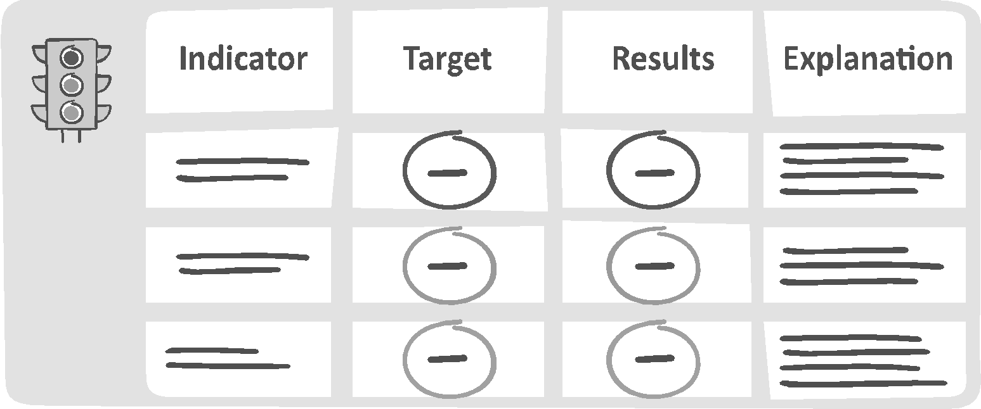

Depending on your data, your stakeholders and your capacities, you will decide which tool is best for presenting data. Either way, to ensure that the M&E data get used, you will have to invest time in helping your team familiarize themselves with the idea of looking at findings and drawing conclusions.[74]

From M&E data to action

As you slowly begin to get used to relying on M&E data, it also becomes easier to incorporate new insights into the decision-making process and more importantly, to plan how to move forward in your peacebuilding efforts.

Essentially, you are building a learning cycle that continues to shape the design, implementation and assessment of the work. The five steps of the M&E plan start over again each time...

Setting up a series of strategic conversations to accompany each phase of your M&E plan will help build

consensus on how to make ongoing adjustments to your work.



Building a Culture of M&E - Worksheet

Once key conclusions have been drawn from your M&E data, you will want to facilitate conversations that are focused on setting recommendations for action. In order to build consensus around these issues, you can pose broader questions such as:

* What are we seeing in our M&E data that we did not expect? What types of issues are we seeing come up again and again?
* ________________________________________________________________________________________________________________________________________________________________________________________________________________________________________________________________________________________________________________________

For specific projects, you can ask questions such as...

* What is going well in our project? Why so?

________________________________________________________________________________________________________________________________________________________________________________________________________________________________________________________________________________________________________________________

* What does this mean for our work moving forward? What are the next steps?

________________________________________________________________________________________________________________________________________________________________________________________________________________________________________________________________________________________________________________________

And then of course, you want to make sure that you consider your challenges...

* What are the types of problems we are having? Why so? ________________________________________________________________________________________________________________________________________________________________________________________________________________________________________________________________________________________________________________________
* What does this mean for our work in the future? What are the next steps? ________________________________________________________________________________________________________________________________________________________________________________________________________________________________________________________________________________________________________________________

What happens when we don’t get good news?

We must be open to the possibility that we might not be 100% content with our M&E findings. In fact, we should expect that there will always be room for improvement. Difficult results may be accompanied by some feeling of frustration or disappointment. Then it will be more important than ever to facilitate conversations that can move your organization forward. You need to keep reminding everyone to fully expect continual adjustments as needed.

Managing Change

Not surprisingly, tension and conflict are possibilities at this critical stage. After all, there is passion and emotion here- as we all tend to be quite committed to the work that we are carrying out to build a more peaceful reality. And we also are quite used to the status quo, likely well- accustomed to our routines and way of operating.[75] Change is hard, even when it is for the better. We may be working towards social change, but this doesn’t mean that we always happily embrace change in our day-to-day work.

So as you revisit your theory of change and consider various aspects of your organizational, programmatic and operational strategy in light of M&E findings, keep in mind there very well might be new challenges.[76] Any strategic shift in the organization can understandably lead to fear or anxiety on the part of your team and/or key stakeholders.[77] During these times of transition, it is vital to communicate with each group in order to maintain their commitment.

As we know, peacebuilding work can be very demanding, fast-paced and labor intensive. If there is a need for strategic shifts, remember to explore how members of your team are rewarded for taking on new responsibilities, embracing new directions or instituting new patterns of behavior.

Several options that should help in this regard include staff training, formal mentoring opportunities, and improved supervisory practices and communication protocols especially if there is little flexibility in financial compensation.

During times of transition, additional staff support and guidance may be especially welcomed. Sensitivity to all kinds of concerns regarding change in the daily work is vital. To effectively address the variety of possible obstacles to your change efforts, you will want to deal with implementation issues directly.

Managing Change - Worksheet

Any shift in strategy should be a choice that your team and key stakeholders are easily able to imagine. Your team and your board members should be able to envision their role in the process and understand what actions are needed. To effectively address the variety of possible obstacles you might encounter, update your strategic tools like your theory of change and your new workplan with your team.[78]

You want to have clarity about what is staying the same, what is being initiated, and what is not being continued. It is critical to consider how your current organizational infrastructure meets any new needs. Don’t forget to check, for example, if staff have the necessary training for new roles, or if current staff are overcommitted to other activities. All of this will affect your organization’s abilities to make change.

When updating your strategy/program, ask yourself the following questions:[79]

* What is the particular kind of change that you would like to see? ______________________________________________________________________________________________________________________________________________________________________

* Which changes should you focus on? ______________________________________________________________________________________________________________________________________________________________________
* What are the specific steps needed in order for you to bring about this change? ______________________________________________________________________________________________________________________________________________________________________
* Who is responsible for each step as outlined? ______________________________________________________________________________________________________________________________________________________________________
* What is your timeline for completing each of these particular steps? ______________________________________________________________________________________________________________________________________________________________________
* What are the exact resources needed (including financial, administrative and expertise)? ______________________________________________________________________________________________________________________________________________________________________

Through efforts such as updating your theory of change and clearly outlining implementation guidelines, you are working to translate strategies into specific action items. You can outline the concrete steps as needed. Your workplans and theory of change/ logical framework should ask specific questions like what are the tasks that need to be accomplished, who is responsible for them, and how and when should they be completed.

Drawing up workplans together with budget plans helps ensure that sufficient resources are available and are allocated in a way that reflects any new organizational priorities. Workplans should be modified as needed to reflect changing circumstances or new insights. Your strategies will not stay static; rather they will develop based on organizational experimentation and experience.

Your M&E efforts can help you to manage change. Your organization will be better able to outline detailed steps toward progress and build a shared vocabulary. Having a mutual understanding of what your peacebuilding efforts look like in everyday practice helps to reduce ambiguity, while better enabling you to track your impact over time. As needed, you can make sure to set aside time for the transition and for the development of new norms and routines.

And of course, you will want to create opportunities for ongoing feedback from staff members and others involved in the implementation that allows for needed modifications to the workplans and the planned strategy.

Section 4: Communicating and Sharing Your Story

Sharing M&E Data with Stakeholders

After so much work, so much data collection and so many efforts to engage and advance desired outcomes in your peacebuilding efforts, you will also want to consider how to communicate your accomplishments to the rest of the field. In this section, we discuss ideas for sharing your M&E findings and organizational story with key audiences such as social media, your funders, news outlets, partner organizations and your extended community. By now you have hopefully gained a certain comfort level in creatively presenting information to your various audiences.

It is well worth your time and effort to think through in what form and at what pace you want to share your M&E findings. Make sure to adapt your communication style and materials to each audience, always telling your story and sharing insights about your work. Set the stage for the findings, including articulating your theory of change and how you have already used or plan to use your findings going forward. Use your data to tell a story about why your programs are showing progress and even more importantly, why this all matters.

Transparency

As we know, ethical challenges arise at all stages of the work and in the M&E process as well. Make sure to **be careful of ethical challenges around data-sharing such as data privacy** in sharing your M&E findings.

Consider also how you are adhering to values of honesty, accuracy and humility when presenting findings. It is important to **detail the data collection methodology** and as previously noted, outline the limitations of the process.

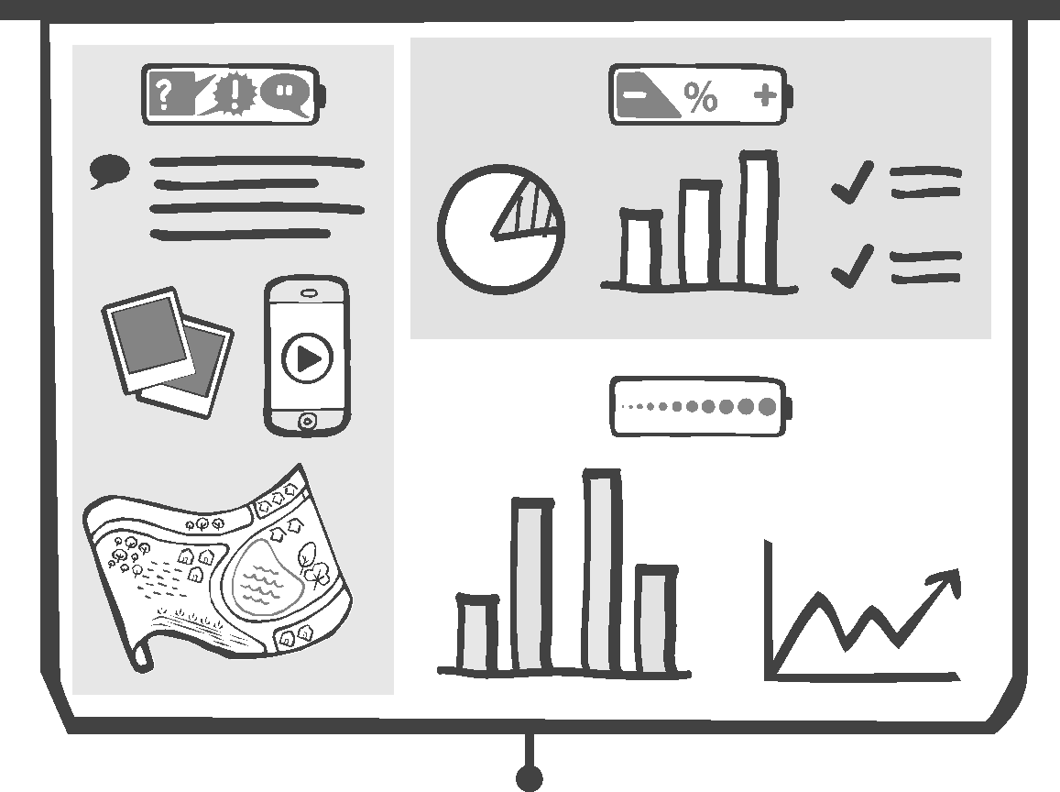

Staying transparent will help keep you accountable. This may be the time to have frank conversations with your stakeholders about what is actually possible moving forward given what is working and what you learned is not working in your peacebuilding efforts. In light of the M&E data, you may find that you need to adapt your day-to-day efforts to a new reality and adjust expectations accordingly. Having a shared understanding of your next steps and plans will serve you well.

|  |  |
| --- | --- |
| Communicating your M&E data | |
| Why is this important?   * Help stakeholders stay informed and make data driven decisions. * Nurture trust with your community and promote greater transparency. * Share the lessons learned with the rest of the field. * Raise community awareness about your efforts. | Some key ideas to keep in mind…   * Explain the ‘so what’ of the information to stakeholders, and why that matters. * Select data presentation methods that meet the needs of various audiences. * Provide a needed context for your data as part of a larger story. * Engage your supporters as storytellers and champions of your work. * Think about how you are building community and expanding your outreach. |



|  |  |  |  |  |
| --- | --- | --- | --- | --- |
| c Communicating with Stakeholders - Worksheet  In developing an approach to communicating with various audiences, consider questions such as:   * How are you helping the audience to connect to the findings? Are you explaining its relevance to their lives?   ______________________________________________________________________________________________________________________________________________________________________________________________________________________________________________________  __________________________________________________________________________________   * What should be the tone and style of your communications in this setting- a formal, more respectful tone or a more simple, casual tone?   ______________________________________________________________________________________________________________________________________________________________________________________________________________________________________________________  __________________________________________________________________________________   * What is this audience most interested in learning about regarding your project?   ______________________________________________________________________________________________________________________________________________________________________________________________________________________________________________________  __________________________________________________________________________________   * What are the key pieces of information or specific recommendations that you should communicate?   ______________________________________________________________________________________________________________________________________________________________________________________________________________________________________________________  __________________________________________________________________________________   * Which type of data presentation is most appropriate in this setting?   ______________________________________________________________________________________________________________________________________________________________________________________________________________________________________________________  __________________________________________________________________________________  **Storytelling**  With all the peacebuilding efforts that you are championing every day, more storytellers would be welcomed to bring these topics to the attention of the greater public. This would energize you as well and validate your efforts.  It also makes sense to share stories in a way that includes your audience in the solution.[80] You can keep in mind questions such as: What draws people to action? What convinces them to listen, to make a tough decision?  Remember that you can look at this type of communication as a way to continue reaching out, building your movement, and gaining more support for your efforts.  What stories to tell? (Ganz, 2009)  Consider how you are issuing a call to action when you tell stories about your own personal connection to the type of peacebuilding work that you are engaged in.[81] Present it in a way that gives your listeners a ready pathway into your world.  Knowing what you are as an organization, where you want to go, and how you are getting there – these are the stories your stakeholders want to hear. This will motivate more people to get involved with your efforts. Make the link by considering how you tell “the story of self, the story of us” and “the story of now” as explained below. | | | | |
|  |  | |  | |
| The story of self | The story of us | The story of now | |
| What is unique about yourself?  What have you overcome?  What have you learned?  Why are you connected to this organization?  How has that commitment affected your life? | What is a common experience we share?  How are we each affected by this issue?  Why is this topic of relevance? | Why is this a problem of urgency?  How can we become ready to address it?  What can we hope to achieve?  Which specific steps can be of use? | |



Through the many tools referred to in these pages, through the stories you tell and through the real impact your organization is making, you will motivate more people to get involved with your important peacebuilding efforts.





M&E Summary - Worksheet

In the beginning of this workbook, we said that the purpose of strategic thinking through M&E is to clarify and understand your impact. Now, without looking back on the work you have done in the rest of this book, you should be able to fill in these answers easily and seamlessly.

* Our organization hopes to achieve:

______________________________________________________________________________________________________________________________________________________________________________________________________________________________________________________________________________________________________________________________________________________________________________________________________________________________________________________________________________________________________________________________

* So our organization does

______________________________________________________________________________________________________________________________________________________________________________________________________________________________________________________________________________________________________________________________________________________________________________________________________________________________________________________________________________________________________________________________

* And these efforts are resulting in

______________________________________________________________________________________________________________________________________________________________________________________________________________________________________________________________________________________________________________________________________________________________________________________________________________________________________________________________________________________________________________________________

* We can ensure that these efforts are leading to desired results by measuring:

____________________________________________________________________________________________________________________________________________________________________________________________________________________________________________________________________________________________________________________________________________________________________________________________________________________________________________________________________________________



Summing up

We move forward depending on the questions that we ask and the conversations that we have. This is one of the most significant benefits of an M&E process.

It is the result of the simple idea that you build the capacity of your organization when you engage with your community and adapt your efforts as you go. With the help of the many tools presented, you can help guide your organization and enhance your team’s ability to plan, think and act strategically.

We once read that “*the organization of hope is what makes hope reasonable*.”[82] It seems that this is a perfectly apt quote with which to end. It reminds us to think about the function of both M&E and the strategic thinking that underpins our organization. And it reminds us to stay optimistic despite all, with perhaps just a little dose of skepticism.

In bringing hope to others, you are making an impact - helping to effect a more peaceful reality that is so needed in the world today.

For more information…

Don’t forget to check out [www.amal-tikva.org/resources](http://www.amal-tikva.org/resources) for the full M&E Guidebook written by   
Dr. Nancy Strichman. And for sample worksheets and practical case studies see [www.amal-tikva.org/resources](http://www.amal-tikva.org/resources).

**Endnotes**

1. See International Program for Development Evaluation Handbook IPDET, World Bank, Carleton University <https://ieg.worldbankgroup.org/sites/default/files/Data/reports/ipdet.pdf>  (2013) for an overview of the evaluation process.
2. See Strichman, N. et al. (2011). Guide to Strategic Thinking for Social Change. Shatil: Israel and, for more on vision processes, see. Angelica, E. (2001) Crafting Effective Mission and Vision Statements.
3. For more on the problem tree analysis, see ODI Toolkit, Successful Communication, A Toolkit for Researchers and Civil Society Organisations. [www.odi.org/publications/5258-problem-tree-analysis](http://www.odi.org/publications/5258-problem-tree-analysis).
4. When you begin to identify strategic concerns, make sure that you give your organization the time to focus first on defining the issues. Often conflicts may arise over possible solutions before the problem itself has been defined properly by your organization. See Fisher, R. & Ury, W. (1981) Getting to Yes: Negotiating Agreement Without Giving In. New York: Penguin Books
5. For more information on how to carry out a stakeholder analysis for community development and nonprofits, see Civicus toolkits at <https://www.civicus.org/index.php/media-center/resources/toolkits/civicus-resources/organisational-plannin>

   and <https://www.thegrassrootscollective.org/stakeholder-analysis-nonprofit>
6. For more on listening and conversations, see Time to Listen: Hearing People on the Receiving End of International Aid, (2015) Anderson, M., Brown, D., & Jean, I. CDA;<https://reliefweb.int/sites/reliefweb.int/files/resources/Time%20to%20Listen%20Hearing%20People%20on%20the%20Receiving%20End%20of%20International%20Aid.pdf> And on gender sensitivity, for example, see Integrating Human Rights and Gender Equality in Evaluations (2018) United Nations Evaluation Group (UNEG)
7. See Considering Evaluation: Thoughts for Social Change and Movement-Building Groups. Borgman-Arboleda, C. & Clark, H. <https://www.actknowledge.org/resources/documents/ACT_K_layout6909hr.pdf> Act Knowledge for more information on evaluation for practitioners working to build organizations, organize networks, alliances and movement building. 
8. For more guidance, see <https://www.thegrassrootscollective.org/problem-objective-tree-development>
9. For carrying out a conflict analysis in depth, see CONDUCTING A CONFLICT AND DEVELOPMENT ANALYSIS by United Nations Development Group <https://unsdg.un.org/sites/default/files/UNDP_CDA-Report_v1.3-final-opt-low.pdf>
10. Cited from Agiamondo (2019) (ed.: Kuijstermans, C.): Managing Outcomes. A Practitioner’s Manual For Analysis, Planning, Monitoring and Self-Evaluation based on Outcome Mapping. Köln: Agiamondo, p. 24-25
11. Cited from Agiamondo (2019).
12. Cited from Agiamondo (2019).
13. For a full discussion of conflict assessment, see USAID Conflict Assessment Framework at <https://pdf.usaid.gov/pdf_docs/PNADY740.pdf>. Also see Measuring the Un-Measurable: Solutions to Measurement Challenges in Fragile and Conflict-affected Environments. (2013) DFID, Corlazzoli, V. &White, J.; OECD Guide to Evaluating Peacebuilding Activities (2012).
14. Another approach for similar goals is known as outcome mapping. Balls, E. & Nurova, N. (2020): [Outcome mapping and research into use: analysing monitoring data for effective strategie](https://doi.org/10.1080/09614524.2019.1701989)s, Development in Practice, DOI: 10.1080
15. For examples, see Organizational Research Services (2004). [Theory of Change: A Practical Tool for Action, Results and Learning.](https://www.aecf.org/resources/theory-of-change/) Prepared for Anne E. Casey Foundation. The DAC Network on Development Evaluation and the DAC Network on Conflict and Fragility (INCAF); Church, C. & M. Rogers. 2006. “Designing for Results: Integrating Monitoring and Evaluation in Conflict Transformation Programs.” Search for Common Ground
16. To explore links to broader organizational learning, see [Making Evaluations Matter: A Practical Guide for Evaluators](https://www.betterevaluation.org/en/resources/guide/making_evaluations_matter), Kusters, c. et al. / Center for Development Innovation (2013)
17. For more about advocacy and policy change, see [A User’s Guide to Advocacy Evaluation Planning.](http://www.pointk.org/resources/node/460#:~:text=Julia%20Coffman%20of%20Harvard%20Family,advocacy%20evaluation%20outcomes%20and%20methods.) (2009) Coffman, J. Harvard Family Research Project.
18. For an in depth discussion of “Do no harm’in conflict settings, see the CDA Practional Learning for International Action at <https://cdacollaborative.org/what-we-do/conflict-sensitivity/?src=handout>
19. For practical examples of assumptions, see Catholic Relief Services’ [Guidance for Developing Logical and Results Frameworks](https://www.dmeforpeace.org/resource/catholic-relief-services-guidance-for-developing-logical-and-results-frameworks/) (2017). Levine, C
20. Detailed discussion of risks can be found in Tools for Development: A handbook for those engaged in development activity. DFID Department for International Development (2003).
21. Adapted from Department for International Development (2003). Tools for Development: A handbook for those engaged in development activity. p. 6.3
22. See Allison, M. & Kaye, J. (2005). Strategic Planning for Nonprofit Organizations and for a full discussion of strategic planning tools, see Strichman, N. et al. (2011). Guide to Strategic Thinking for Social Change. Shatil: Israel. (In Hebrew, Arabic and English).
23. For more details about strategic planning see : [Strategic Planning Toolkit](https://www.civicus.org/view/media/Strategic%20Planning.pdf) Shapiro. J. CIVICUS. <https://www.civicus.org/index.php/media-center/resources/toolkits/civicus-resources/organisational-planning>
24. For a full discussion of strategic planning tools, see Strichman, N. et al. (2011). Guide to Strategic Thinking for Social Change. Shatil: Israel. (In Hebrew, Arabic and English).
25. Patton, M.Q. (1997). Utilization- Focused Evaluation. 3rd Ed. Thousand Oaks, CA: Sage Publications; Hernandez, G. and Visher, M. G. (2001) Creating a Culture of Inquiry: Changing Methods- and Minds- on the Use of Evaluation in Nonprofit Organizations. San Francisco: James Irvine Foundation;
26. Patton, M.Q. (1997). Utilization- Focused Evaluation. p. 196
27. See [W.K. Kellogg Foundation Logic Model Development Guide](https://www.wkkf.org/resource-directory/resources/2004/01/logic-model-development-guide), 2004. See BOND- Networking for International Development
28. For more on the use of visualization and participatory methods in all types of planning and evaluation, see [Introduction to PRA Visualisation Methods](https://www.participatorymethods.org/resource/introduction-pra-visualisation-methods) (1999), Cornwall, A. Institute for Development Studies. Includes explanation of tools such as mapping, transect walks, timelines and historical maps, problem walls and solution trees.
29. See Anderson, A. The Community Builder’s Approach to Theory of Change: A Practical Guide To Theory Development. See also Theory of Change Methodological Briefs – Impact Evaluation No. 2. (2015) Rogers, P. UNICEF.
30. Additional guidance on outcomes, can be found, for example, at Earl, S., Carden, F., & Smutylo, Q. (2001). [Outcome mapping: building learning and reflection into development programs](https://www.betterevaluation.org/en/resource/outcome_mapping)​, Ottawa: International Development Research Centre.
31. For more samples, see Anderson, A. The Community Builder’s Approach to Theory of Change: A Practical Guide To Theory Development. And see also Theory of Change Methodological Briefs – Impact Evaluation No. 2. (2015) Rogers, P. UNICEF.
32. For examples, see [Examples of Theory of Change](https://assets.publishing.service.gov.uk/media/57a08a66ed915d622c000703/Appendix_3_ToC_Examples.pdf). Collated by Vogel, I. and Stephenson, I. DFID EVD, July 2012
33. For participatory approach to indicators [Equal Access Participatory Monitoring and Evaluation Toolkit](https://www.betterevaluation.org/en/toolkits/equal_access_participatory_monitoring) Lennie, J., Tacchi, J., Koirala, B., Wilmore, M., Skuse, A. (2011) Equal Access Participatory Monitoring and Evaluation toolkit.
34. For field-based efforts, see for example, [Violence Against Women and Girls: A Compendium of Monitoring and Evaluation Indicators](https://www.measureevaluation.org/resources/tools/gender/violence-against-women-and-girls-compendium-of-indicators) (2014) Bloom, S. USAID, IGWG and MEASURE Evaluation
35. A detailed discussion of peacebuilding indicators can be found at Catholic Relief Services GAIN Peacebuilding Indicators Report, 2010 at <https://www.crs.org/sites/default/files/tools-research/gain-peacebuilding-indicators.pdf>
36. For the sake of space we will only refer to the difference in qualitative and quantitative approach in terms of methodology and data collected. See Research Method’s Knowledge Base at <http://www.socialresearchmethods.net/kb/qualdeb.htm4> for insight into the ongoing “qualitative-quantitative debate”. For more information about a pragmatic approach of mixed-method methodologies see National Science Foundation’s Directorate for Education and Human Resources at <http://www.ehr.nsf.gov/EHR/REC/pubs/NSF97-153/CHAP_1.HTM>
37. For detailed examples see Civicus toolkits at <https://www.civicus.org/monitoring-toolkits/toolkit/indicators/>
38. A toolkit on indicators can be found at Civicus toolkits at <https://www.civicus.org/monitoring-toolkits/toolkit/indicators/>
39. For participatory approach to indicators Equal Access Participatory Monitoring and Evaluation Toolkit Lennie, J., Tacchi, J., Koirala, B., Wilmore, M., Skuse, A. (2011) Equal Access Participatory Monitoring and Evaluation toolkit. For example, specifically on peacebuilding indicators, see Theories and Indicators of Change: Concepts and Primers for Conflict Management and Mitigation ( 2005) USAID, AMEX, Babbitt, E. Chigas, E.& Wilkenson, R
40. See Rossi, P. H., & Freeman, H. E. (1993). Evaluation: A systematic approach (5th ed.). Newbury Park, CA: Sage Publications. For more on research methods, see Skovdal, M and Cornish, F., (2015) Qualitative Research for Development And A Guide to Using Qualitative Research Methodology MSF Medecins Sans Frontiers, 2015, Bricki, N & Green, J.
41. While there are a variety of types of evaluation and of research, it is possible to make the following distinction as defined by Patton, 2002: “the purpose of evaluation is to produce useful information for program improvements and decision making. And the purpose of research is to produce knowledge about how the world works.” For more information about the higher ‘standards of evidence’ required for research, see Research Method’s Knowledge Base at <http://www.socialresearchmethods.net/kb/>
42. For more about interviews and additional references, See [DFID Introduction to Qualitative Research Methodology, Kielmann, K., Cataldo, F. & Seeley, J. (2011).](http://betterevaluation.org/resources/guides/Intro_Qual_Research_Methodology) For sample interview protocols, see Online Evaluation Resource Library at <http://www.oerl.sri.com/instruments/instruments.html>. And Morra Imas and Rist (2009). The Road to Results: Designing and Conducting Effecting Development Evaluations.
43. See Patton, M.Q. (2002) Qualitative Research and Evaluation Methods. 3rd Edition. Thousand Oaks, CA: Sage Publications, p. 341. [A Guide to Using Qualitative Research Methodology](https://www.dmeforpeace.org/resource/a-guide-to-using-quantitative-research-methodology/) MSF Medecins Sans Frontiers, 2015, Bricki, N & Green, J
44. In J. S. Wholey, H. P. Hatry, & K. E. Newcomer (Eds.), Handbook of practical program evaluation (pp. 374-385). San Francisco: Jossey-Bass Publishers.
45. See Online Evaluation Resource Library at <http://www.oerl.sri.com/instruments/instruments.html>
46. For more on observation as a data tool see International Program for Development Evaluation Training Module on Data Collection at <http://www.worldbank.org/oed/ipdet/modules.html>
47. See Online Evaluation Resource Library at <http://www.oerl.sri.com/instruments/instruments.html> for examples of observation guides and checklists for observations.
48. Also see [DFID Introduction to Qualitative Research Methodology, Kielmann, K., Cataldo, F. & Seeley, J. (2011).](http://betterevaluation.org/resources/guides/Intro_Qual_Research_Methodology)
49. See Skovdal, M and Cornish, F., (2015) [Qualitative Research for Development](http://www.orange.ngo/wp-content/uploads/2017/02/Qulittive-Research-for-Development.pdf)
50. See [DFID Introduction to Qualitative Research Methodology, Kielmann, K., Cataldo, F. & Seeley, J. (2011).](http://betterevaluation.org/resources/guides/Intro_Qual_Research_Methodology)For participatory monitoring and evaluation (PME) in rural development, see [Participatory Monitoring and Evaluation Field Experiences](https://www.fsnnetwork.org/participatory-monitoring-and-evaluation-field-experiences) (2005) India. NGO Programme Karnataka-Tamil Nadu
51. For more on community mapping and other participatory approaches, see [VSO Facilitator guide to participatory approaches.](https://www.participatorymethods.org/sites/participatorymethods.org/files/VSO_Facilitator_Guide_to_Participatory_Approaches_Principles.pdf) Bradley, D. & Schneider, H. 2009 Voluntary service Overseas.
52. Also see [Guide to Using Qualitative Research Methodology](https://d.docs.live.net/adffb82d8a61c574/Guide%20to%20Using%20Qualitative%20Research%20Methodology) MSF Medecins Sans Frontiers, 2015, Bricki, N & Green, J. <https://www.alnap.org/help-library/a-guide-to-using-qualitative-research-methodology>
53. See [Guide to Using Qualitative Research Methodology](https://d.docs.live.net/adffb82d8a61c574/Guide%20to%20Using%20Qualitative%20Research%20Methodology) MSF Medecins Sans Frontiers
54. See International Program for Development Training's Module on Data Collection Methods at <http://www.worldbank.org/oed/ipdet/modules.html>
55. For more, see Chapter 8: Selecting and Constructing Data Collection Instruments. [The Road to Results: Designing and Conducting Effecting Development Evaluations.](https://openknowledge.worldbank.org/bitstream/handle/10986/2699/52678.pdf?sequence=1&isAllowed=y) (p. 289-349)
56. Barry, B. (1997) Strategic Planning Workbook for Nonprofit Organizations.
57. For more on the ethics and sensitivities of data collection see Morra Imas and Rist (2009). The Road to Results
58. See Chapter 10: Choosing the Sampling Strategy. Morra Imas and Rist (2009). The Road to Results (p. 355-367). For more information about different kinds of sampling, see Research Method’s Knowledge Base at <http://www.socialresearchmethods.net/kb/sampterm.htm>
59. See International Program for Development Evaluation Training's Module on Data Analysis and Interpretation at <http://www.worldbank.org/oed/ipdet/modules/M_08-na.pdf> or Research Methods Knowledge Base at <http://www.socialresearchmethods.net/kb/analysis.ht>
60. For participatory approach to data analysis see [Equal Access Participatory Monitoring and Evaluation Toolkit](https://www.betterevaluation.org/en/toolkits/equal_access_participatory_monitoring) Lennie, J., Tacchi, J., Koirala, B., Wilmore, M., Skuse, A. (2011) Equal Access Participatory Monitoring and Evaluation toolkit.
61. Chapter 10 Planning For and Conducting Data Analysis. [The Road to Results: Designing and Conducting Effecting Development Evaluations.](https://openknowledge.worldbank.org/bitstream/handle/10986/2699/52678.pdf?sequence=1&isAllowed=y) (p. 373-404).
62. For more information on qualitative data analysis see the cited resources and Research Methods Knowledge Base at <http://www.socialresearchmethods.net/kb/analysis.htm>
63. [A Guide to Using Qualitative Research Methodology](https://www.dmeforpeace.org/resource/a-guide-to-using-quantitative-research-methodology/) MSF Medecins Sans Frontiers, 2015, Bricki, N & Green, J
64. For participatory approach to data analysis see [Equal Access Participatory Monitoring and Evaluation Toolkit](https://www.betterevaluation.org/en/toolkits/equal_access_participatory_monitoring) Lennie, J., Tacchi, J., Koirala, B., Wilmore, M., Skuse, A. (2011) <https://www.betterevaluation.org/en/toolkits/equal_access_participatory_monitoring>
65. For more about facilitating learning from evaluation and reviewing data, see Preskill, H. and Torres, R. (1999) Evaluative Inquiry for Learning in Organizations. Thousand Oaks, CA: Sage.
66. For more on this topic, see: Presenting Results, Chapter 13 in [The Road to Results: Designing and Conducting Effecting Development Evaluations.](https://openknowledge.worldbank.org/bitstream/handle/10986/2699/52678.pdf?sequence=1&isAllowed=y) (p.467-491).
67. For more information about using graphics to report your evaluation results, see [University of WisconsinExtension's Using Graphics to Report Evaluation Results](https://www.betterevaluation.org/en/resources/guides/choose_relevant_report_format/graphics_report_evaluationresults). Minter, E., & Michaud, M. (2003)
68. For more about facilitating learning from evaluation, see Preskill, H. and Torres, R. (1999) Evaluative Inquiry for Learning in Organizations. Also fortips on creating data visualizations. [DME for Peace’s Guidance Note for Producing Data Visualizations](https://www.dmeforpeace.org/resource/dme-for-peaces-guidance-note-for-producing-data-visualizations/)(2019).
69. For more about facilitating learning from evaluation, see Preskill, H. and Torres, R. (1999) Evaluative Inquiry for Learning in Organizations.
70. See Chapter 3 Building a Results-Based Monitoring and Evaluation System. Morra Imas and Rist (2009). [The Road to Results: Designing and Conducting Effecting Development Evaluations.](https://openknowledge.worldbank.org/bitstream/handle/10986/2699/52678.pdf?sequence=1&isAllowed=y) The World Bank (p. 105-135).
71. See Nordell, J (2021). The End of Bias: A Beginning: The Science and Practice of Overcoming Unconscious Bias. Metropolitan Books
72. For more on building a culture of inquiry, see Preskill, H and Torres, R. (2000) “The Readiness for Organizational Learning and Evaluation Instrument (ROLE)” In Preskill, H. and Russ-Eft, D. Evaluation in Organizations. Cambridge, Perseus Publishing.
73. Schein, E. (1992). Organizational Culture and Leadership. 2nd Edition. San Francisco: Jossey Bass.
74. For more information about using graphics to report your evaluation results, see [University of WisconsinExtension's Using Graphics to Report Evaluation Results](https://www.betterevaluation.org/en/resources/guides/choose_relevant_report_format/graphics_report_evaluationresults). Minter, E., & Michaud, M. (2003) and See [International Program for Development Evaluation Training Module on Presenting Results](https://www.betterevaluation.org/sites/default/files/M_11-na.pdf) for M&E findings. IPDET Handbook: “Building a Results-Based Monitoring and Evaluation System.” World Bank.
75. Change tends not to be easy. It can shake up the dynamics in the organization, including the existing patterns of interaction and the current way in which ‘things get done.’ Mintzberg, H. “The Fall and Rise of Strategic Planning”. Harvard Business Review. January- February, 1994; See Bryson, J. (2004). for more details on challenges to implementation.
76. See Strichman, N. et al. (2011). Guide to Strategic Thinking for Social Change. Shatil: Israel. (In Hebrew, Arabic and English).

    and Bryson, J. (2004). Strategic Planning for Public and Nonprofit Organizations.
77. For in-depth research on managing change the adaptive capacity of social change nonprofits in the local context in Israel, Strichman, N., Bickel, W.E., & Marshood, F. (2007). Adaptive capacity in Israeli social change nonprofits. Nonprofit and Voluntary Sector Quarterly, 37(2), 224–248. And Strichman, N., Marshood, F. & Eytan, D. (2018). Exploring the Adaptive Capacities of Shared Jewish-Arab Organizations in Israel VOLUNTAS: International Journal of Voluntary and Nonprofit Organizations, 29 (5), pp 1055–1067.
78. The process that is described is based on evaluative inquiry. See Preskill, H. and Torres, R. (1999) See Bryson, J. (2004). for more details on the development of an implementation plan.
79. See Strichman, N. et al. (2011). Guide to Strategic Thinking for Social Change. Shatil: Israel. (In Hebrew, Arabic and English).

    and Bryson, J. (2004). Strategic Planning for Public and Nonprofit Organizations.
80. For more on the impact of telling personal stories and narratives, see [[“What’s your story? The St Ethelburga’s guide to narrative and story-based approaches to community building”](https://stethelburgas.org/wp-content/uploads/2017/08/STE-Narrative-Guide-28-2-11.pdf)”](https://stethelburgas.org/wp-content/uploads/2017/08/STE-Narrative-Guide-28-2-11.pdf). (2017) St Ethelburga, England.
81. See [“What’s your story? The St Ethelburga’s guide to narrative and story-based approaches to community building”](https://stethelburgas.org/wp-content/uploads/2017/08/STE-Narrative-Guide-28-2-11.pdf). (2017) St Ethelburga, England.
82. Bryson, J. (2004). Strategic Planning for Public and Nonprofit Organizations. p. 32.